Faculty of science
Summer Training Report

Computer science Department – second year - English Section

Supervised By Dr. Mohammad Choker, Dr Samar Chamas

Presented To By Dr. Mohammad Choker, Dr Samar Chamas

Developed by Malak Yazbek, Nour Mrad


August 2025

Acknowledgements

This project is done as a summer training project. We are thankful to our training supervisor, Dr. Mohammad Choker, for his invaluable guidance and assistance, without which the accomplishment of the task would have never been possible. Moreover, we would like to extend our gratitude to Dr. Samar Chamas, Head of computer science Department.
In our present project we have chosen the topic – “Coffee Shop Management System”. Through the process of developing this management system, we had the chance to dig deeper into Java and some other development tools. This report contains the details of our computerized management system which was developed to be implemented specifically in a Coffee Shop.

Contents
Acknowledgements 2
List of Figures 4
Abstract 5
General Introduction 5
1. Chapter 1: Literature Review 7
2. Chapter 2 : System Analysis 11
2.1 Business Requirements : 11
2.2 Activity Diagram : 12
2.3 Use Case Diagram : 14
2.4 Class Diagram : 17
2.5 Conceptual Data Model : 18
3. Chapter 3 : DataBase Implementation 21
3.1 DBMS Advantages : 21
3.2 Database Data Dictionary : 21
3.3 SQL statements 29
4. Chapter 4: Software Implementation 46
4.1 Database Connection String : 46
4.2 Main Programming Tasks : 46
4.2.1 Admin Functions 46
User Management 46
Menu & Book Management 46
Analytics, Reports & Notifications 46
4.2.2 Staff (Cashier) Functions 47
Order Processing 47
Customer Service 47
Book Borrowing 48
Alerts Handling 49
4.3 GUI (Graphical user Interface) : 49
4.4 JAVA Documentation 56
4.4.1 Class Account 56
4.4.2 Class Customer 56
4.4.3 Class MenuItem 57
4.4.4 Class Supplier 58
4.4.5 Class Order 59
4.4.6 Class Book 59
4.4.7 Class BorrowTransaction 60
4.4.8 Class LoyaltyProgram 61
4.4.9 Class Analytics 61
4.4.10 Class Alert 62
4.5 Packages 62
Conclusion and Perspective 63
Bibliography 64

List of Figures

Figure 1: Lightspeed Café 8
Figure 2: Toast POS Café 9
Figure 3: GloriaFood Café 9
Figure 4: Dripos Café 10
Figure 5: GoFrugal Café 11
Figure 6: Activity diagram (Manager) 13
Figure 7: Activity diagram (Cashier) 14
Figure 8: Use Case Diagram 16
Figure 9: Class Diagram 17
Figure 10: Conceptual Data Model 19
Figure 11: Logical Data Model 20
Figure 12: Physical Data Model 45
Figure 13: Login Page 50
Figure 14: Admin Account Managing 50
Figure 15: Users Managing 51
Figure 16: Menu Managing 51
Figure 17: Book Managing 52
Figure 18: Supplier Management 52
Figure 19: Analytics and Reports 53
Figure 20: Staff Account Managing 53
Figure 21: Order Processing 54
Figure 22: Customer Managing 54
Figure 23: Book Borrowing 55
Figure 24: Alert Handling 55

Abstract

Managing a coffee shop using manual records is both time-consuming and inefficient, especially with the increasing demand for speed and accuracy. The proposed computerized system offers an effective solution for local coffee shops by automating daily operations and reducing reliance on traditional paperwork.

This system minimizes the need for physical storage and ensures better security by allowing controlled access to sensitive information. It streamlines the management of employee records, supplier contacts, inventory levels, stock updates, and billing processes. In addition, it simplifies data retrieval, saving both time and administrative costs.

The system also provides visual reports and sales charts, enabling managers to monitor performance and make informed decisions.

In today's fast-paced environment, adopting such a system is not just an upgrade—it's a necessity that enhances efficiency, supports business growth, and ensures a better customer experience.

General Introduction

Old management systems in coffee shops are predominantly paper-based and manual, which often proves to be inefficient and error-prone. These traditional systems require significant human effort, involve a high consumption of paper, and demand physical space for record storage. Moreover, retrieving specific information from such records can be time-consuming and inconvenient, especially during peak business hours.

This project proposes the development of a Coffee Shop Management System as a modern, digital alternative. The system is designed to be deployed on a local machine, providing a centralized solution to manage all operations within a coffee shop — from employee details to inventory, sales, and daily transactions.

The application enables coffee shop owners and staff to maintain their data in an organized, easily accessible format. It provides visual sales summaries and trend analytics, helping managers make informed decisions. The system is built with a user-friendly interface and supports role-based access control, where Managers and Cashiers have different permissions. Managers can oversee operations, update menus, and track sales, while cashiers can quickly process orders and generate invoices.

This solution addresses the limitations of manual and Excel-based tracking methods. It also allows seamless migration by offering options to import product records from existing systems. With this computerized system, common operations like adding, updating, searching, and retrieving data are faster and more efficient, ultimately reducing workload and improving productivity.

The system was developed using NetBeans for the front-end, MYSQL as the database for back-end processing, and Power Designer for creating the Physical, Logical, and Conceptual Data Models. It offers a comprehensive, scalable, and practical tool for local coffee shop businesses transitioning into the digital age.

1. Chapter 1: Literature Review
Comparison may be diminishing the significance of compared systems, but this is an inevitable phenomena in the business world.

Lightspeed Café & Bakery POS
Lightspeed is a cloud-based point-of-sale system that caters specifically to cafés, bakeries, and other food-service businesses. It allows you to manage and customize your entire menu, including modifiers like milk types or pastry options. Its inventory system supports ingredient-level tracking, so you always know when you’re running low on supplies. The platform includes role-based employee access, allowing cashiers, baristas, and managers to use different parts of the system based on permissions. Lightspeed also provides robust offline functionality and detailed reporting dashboards for monitoring sales trends and staff performance.

https://www.lightspeedhq.com/pos/restaurant/bakery-and-cafe-pos-system/

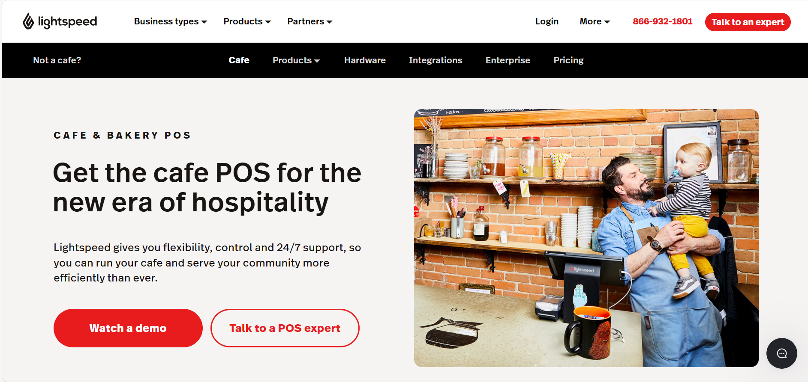
Figure 1: Lightspeed Café

Toast POS for Cafe & Bakery
Toast is a highly popular POS platform designed specifically for restaurants, including small coffee shops and bakeries. It supports intuitive order entry, real-time menu syncing, and mobile/kiosk ordering options to reduce wait times. The system provides detailed analytics and sales reports, helping managers understand customer trends and top-selling items. Employees can clock in/out, and managers can monitor performance through the back office portal. Toast also includes features like loyalty programs, gift cards, and an offline mode to keep your café running even without internet access.

https://pos.toasttab.com/restaurant-pos/cafe-bakery

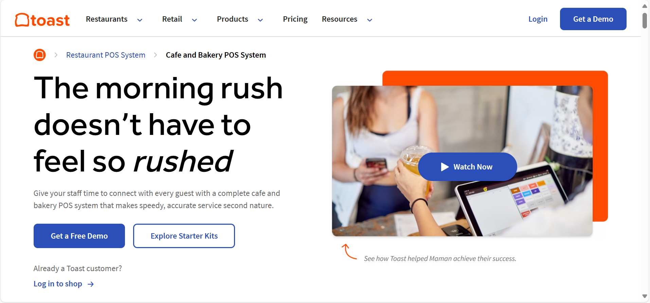
Figure 2: Toast POS Café

GloriaFood – Coffee Shop POS System
GloriaFood provides a specialized POS system for cafés and coffee shops, designed for fast-paced environments with simple order-taking and intuitive menu layouts. It offers offline mode, customizable menus, and tablet-based ordering, ideal for small coffee businesses. Integrated features include inventory tracking, order queuing, delivery integration, and real-time analytics. The system is user-friendly and free to start, making it perfect for independent coffee shops or startups. It also supports integration with kitchen displays and receipt printers for smooth operation.

https://www.gloriafood-pos.com/coffee-shop-pos-system
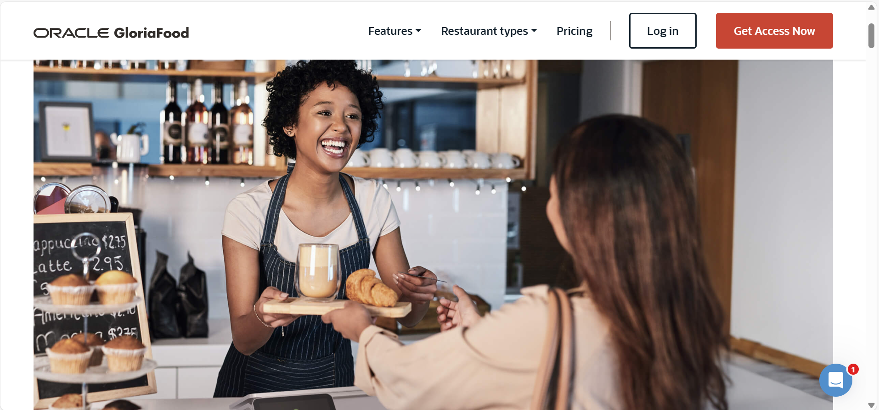
Figure 3: GloriaFood Café

Dripos – All-in-One Coffee Shop POS
Dripos is designed specifically for modern coffee shops, offering a sleek POS experience alongside features like online ordering, loyalty rewards, and payroll. It supports both in-store and mobile orders, with a mobile-first design, ideal for cafes with walk-up or drive-thru windows. The system includes tip management, barista performance insights, and integrated marketing tools like email and push notifications. Inventory management is detailed down to ingredients, which is especially useful for coffee shops tracking beans and add-ons. Dripos stands out for its branding and visual appeal, making it a great fit for stylish or boutique coffee brands.
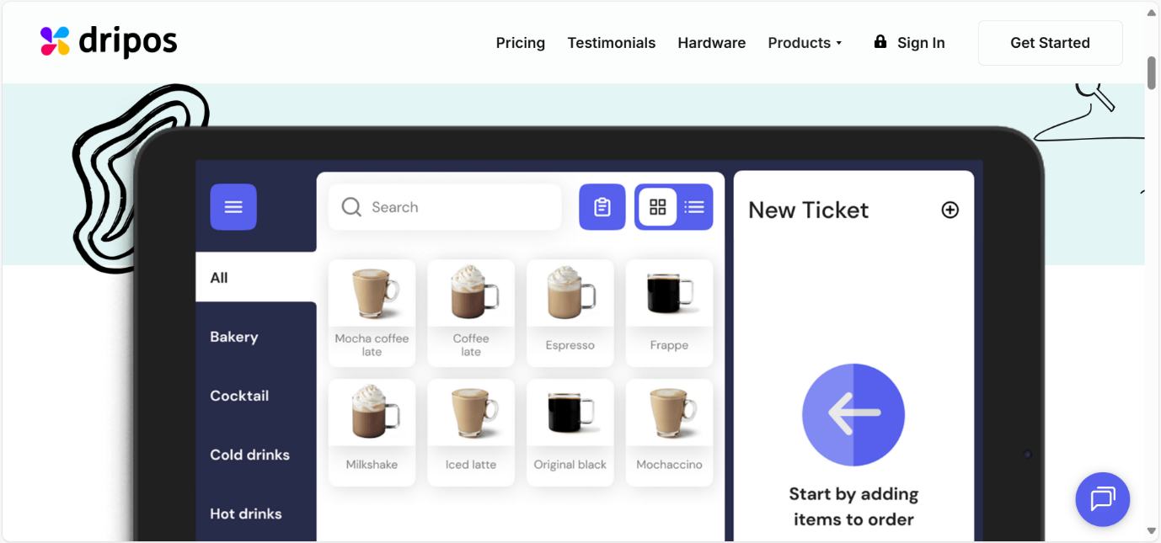
https://www.dripos.com
Figure 4: Dripos Café

GoFrugal – Coffee Shop POS System
GoFrugal’s POS system for coffee shops is part of its broader QSR (Quick Service Restaurant) suite, with fast checkout, combo item management, and recipe-based inventory control. It offers an attractive and responsive interface, tailored for small to medium-sized coffee shops. Managers can access detailed sales analytics, staff performance tracking, and multi-location support. The software also includes customer loyalty tools, SMS/email integration, and 24/7 support. It supports both cloud and offline modes, ensuring uninterrupted operation.

https://www.gofrugal.com/restaurant/quick-service-restaurant-pos/coffee-shop-pos.html

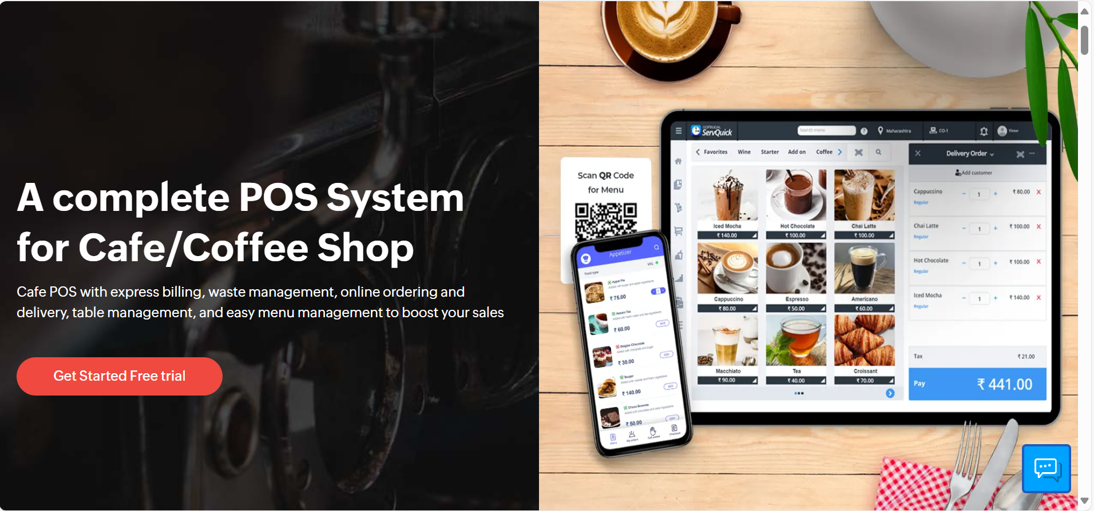
Figure 5: GoFrugal Café

2. Chapter 2 : System Analysis

2.1 Business Requirements :
2.1.1 The Manager has a secure account. This account can be shared between owners or senior staff. They have the right to create new accounts for other managers or cashiers, edit account details, reset or change passwords, and remove accounts of former employees.
2.1.2 Managers can view details of every employee. They can add new employees, update their information, or remove records of resigned employees.
2.1.3 Managers can store and update the contact details of customers, including phone number and loyalty points. Loyalty points are updated automatically when customers make purchases or borrow books.
2.1.4 Managers can add new menu items (coffee, drinks, pastries, etc.) and update their details such as price, stock, category, and image. When stock is replenished, they can record the received order, and the system will automatically update the available quantities.
2.1.5 Managers can manage the book inventory by adding new books under a specified genre, saving author details, ISBN, and stock count. They can update book availability when borrowed or returned.
2.1.6 Managers can record and track book borrow transactions for customers, including borrow date, due date, and return date. If the book is returned late, the system can calculate and record the late fee.
2.1.7 Managers can generate a sales summary report for a specific month or year. This report can include:
- A pie chart showing the most sold product category.
- A line chart summarizing sales over the selected period.
- Calculated total sales revenue and number of products sold.
This report can be saved for future reference.
2.1.8 Cashiers can log in to a simple billing interface where they can add menu items to an invoice, choose quantities, and process payments (Cash, Card, MobilePay). The system automatically calculates the total amount, updates the stock, saves the invoice, and can print a customer copy.
2.1.9 Cashiers can also register a book borrowing transaction if the customer wants to borrow a book while ordering. The system checks the customer’s borrow limit before approving.
2.1.10 Both managers and cashiers can handle returns:
- Product returns update the stock and adjust the original invoice.
- Book returns update the availability status and clear late fees if paid.

2.2 Activity Diagram :
- Login :
Users enter their username and password. The system validates credentials and determines role-based access (Admin, Manager, or Cashier).
- Manager Workflow :
  - After login, managers access the main dashboard.
  - They can choose from:
    - Manage employees
    - Manage customers and loyalty points
    - Manage menu items (add/edit/remove)
    - Manage book inventory (add/edit/remove)
    - Record book borrow/return transactions
    - View and save sales reports
  - Managers can log out after finishing their tasks.
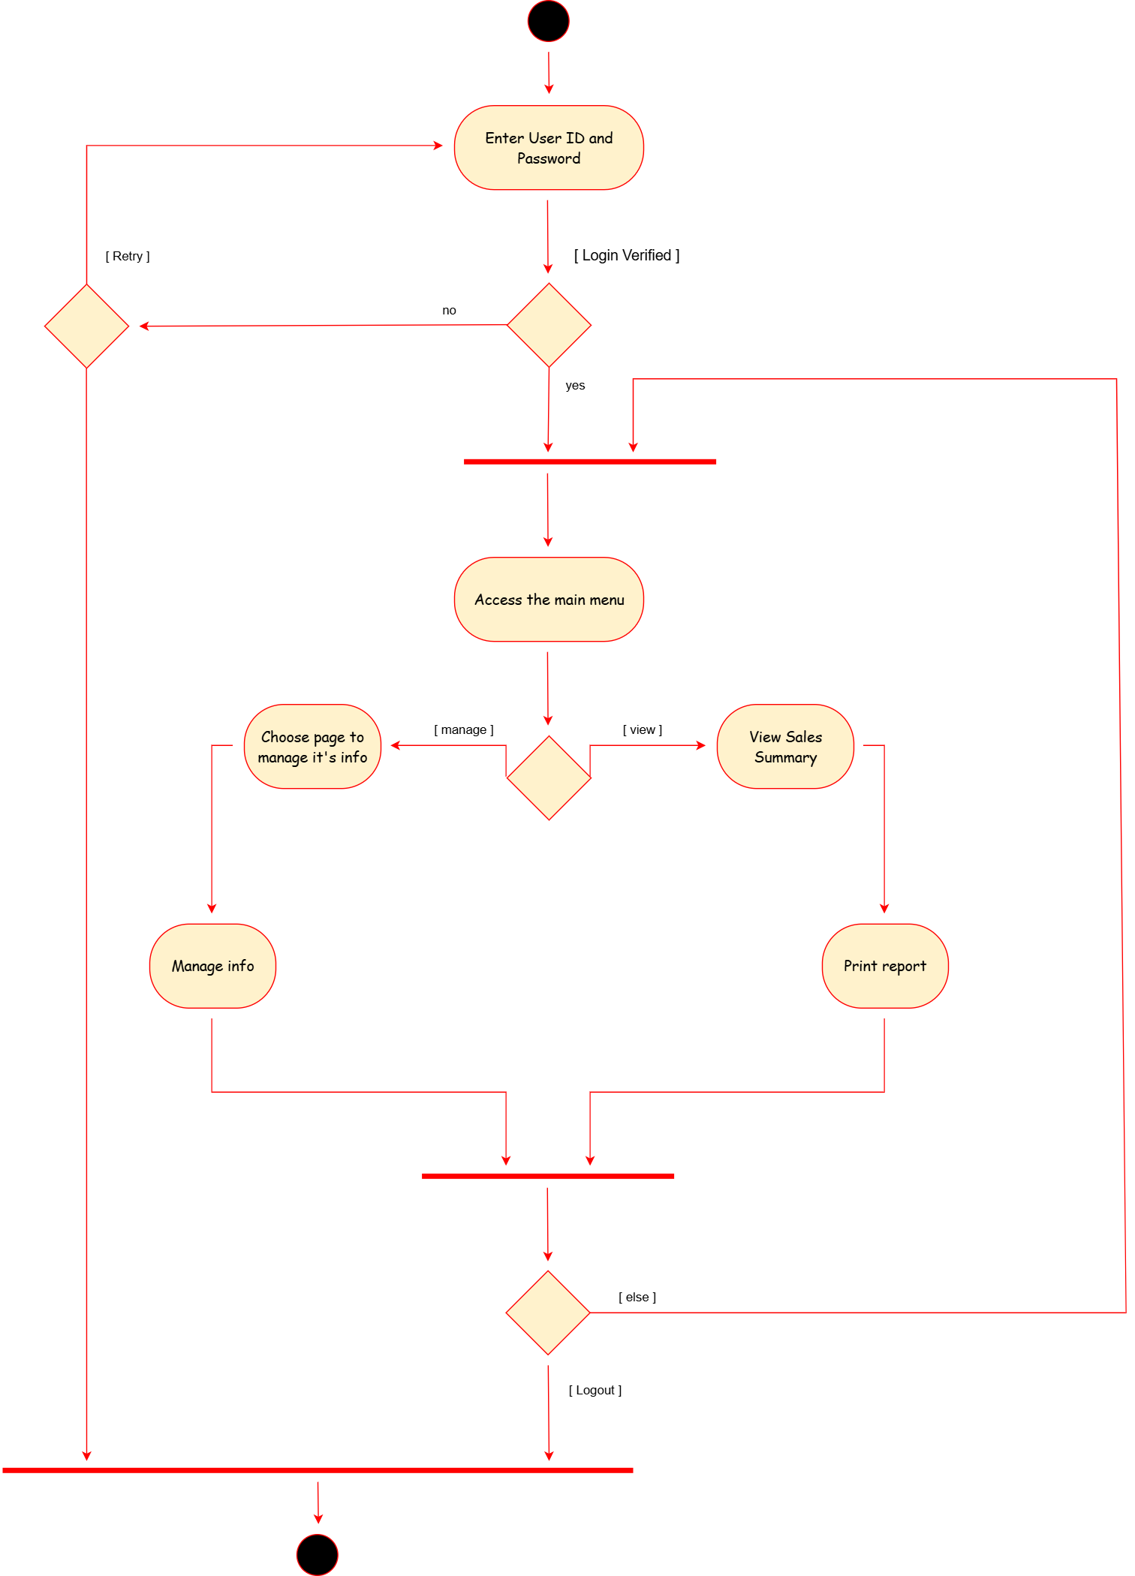
Figure 6: Activity diagram (Manager)
- Cashier Workflow :
  - After login, cashiers access the billing system.
  - They can:
    - Add menu items to an invoice with chosen quantities.
    - Select payment method (Cash, Card, MobilePay).
    - Print the invoice for the customer.
    - Record book borrow transactions for customers.
  - The system automatically updates stock quantities and saves the invoice.
  - After printing, the invoice form clears automatically.
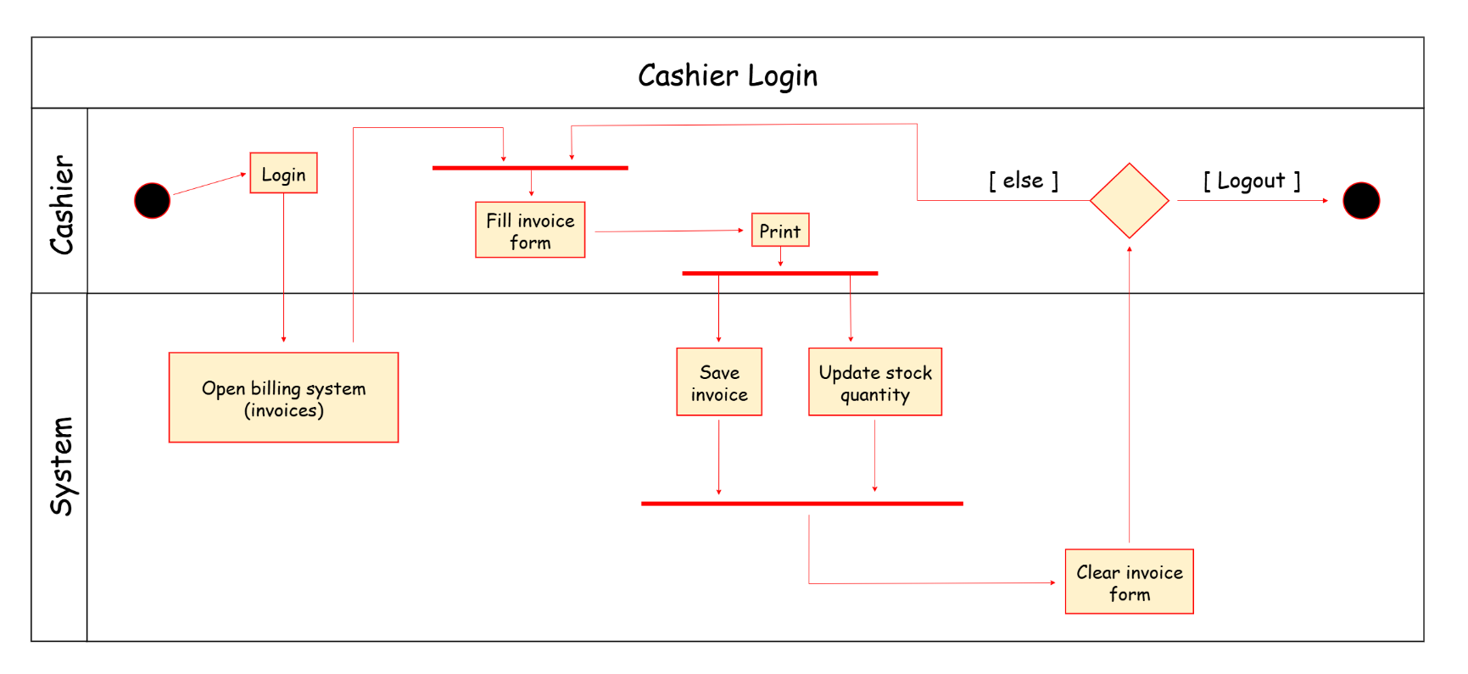
  - Cashiers log out at the end of their shift.
Figure 7: Activity diagram (Cashier)

2.3 Use Case Diagram :
- This system involves two main actors: Managers and Cashiers.
- All users, regardless of their role, must first log in to the system. The system verifies their credentials securely with hashed passwords.
- Managers have broad management capabilities, including:
- Managing the menu by adding, editing, or deleting coffee shop items, such as hot drinks, cold drinks, snacks, and pastries.
- Setting item details such as price, stock quantity, and uploading images.
- Managing staff accounts by creating new user accounts, assigning roles, updating details, resetting passwords, and disabling accounts.
- Overseeing inventory management by tracking stock levels, adding new stock, and receiving alerts on low stock.
- Viewing and editing supplier information, including company details and distributor contacts.
- Generating detailed daily, weekly, and monthly sales reports with graphical summaries like sales by category and payment type.
- Exporting sales summaries as PDF or CSV files for presentations or record-keeping.
- Configuring system settings such as tax rates, payment methods, and printer options.
- Cashiers have a focused role with limited access:
- Taking customer orders using the POS interface, including selecting items, customizing options (e.g., milk type, sugar level), and adding to the cart.
- Processing payments via cash, card, or mobile pay.
- Printing order receipts.
- Automatically updating inventory quantities upon successful sales.
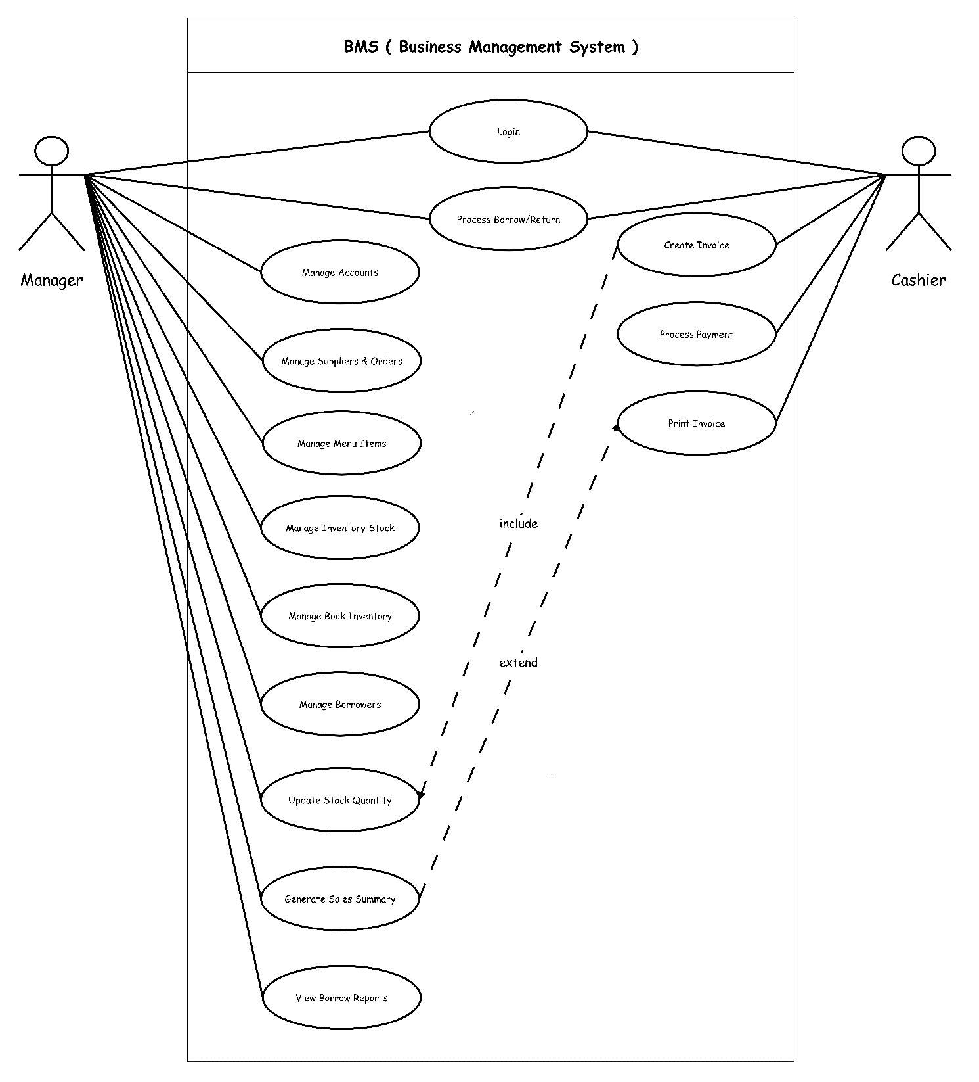

Figure 8: Use Case Diagram

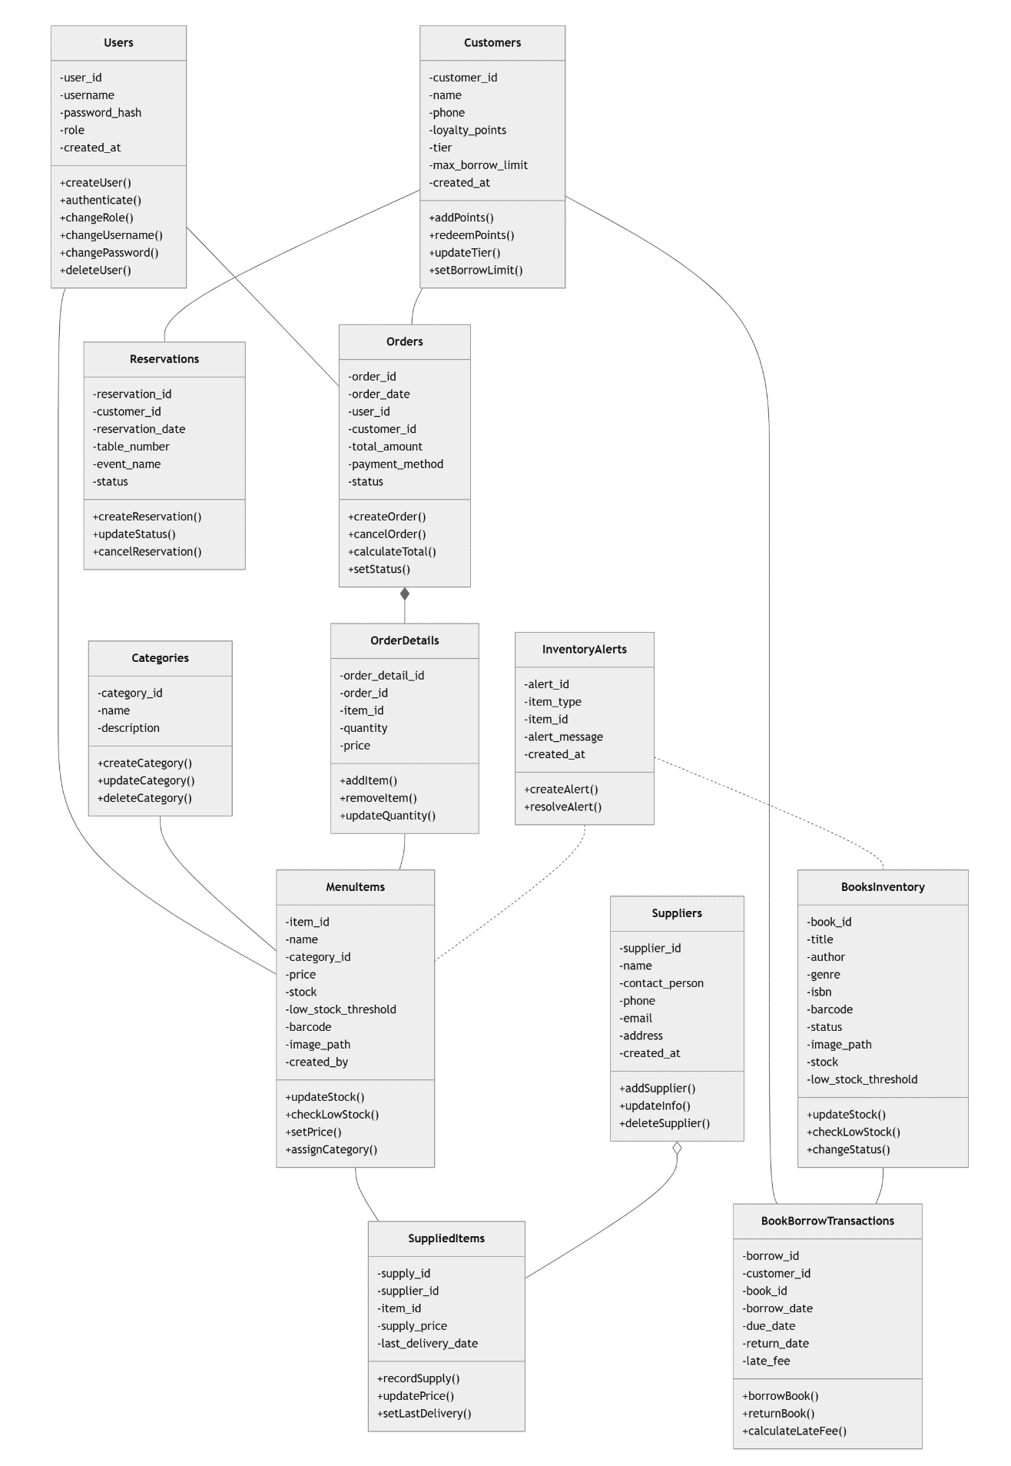
2.4 Class Diagram :
Figure 9: Class Diagram

2.5 Conceptual Data Model :
The system manages various entities including users, customers, items, orders, suppliers, and reservations. Users have roles and credentials to access system functions such as creating users or managing orders. Customers accumulate loyalty points and are assigned tiers that determine their borrowing limits and benefits. Items in the system are divided into two main groups: menu items (such as bakery products, drinks, or sweets) and books available for borrowing. Each item belongs to a category and has attributes like price, stock level, and barcode. Menu items and books both track stock and low-stock thresholds to trigger inventory alerts.
Managers can create and manage categories, and suppliers deliver raw materials or items with details such as supply price and delivery dates recorded. Suppliers belong to companies, and each company can have multiple suppliers operating in different regions. Inventory orders are placed containing raw items from suppliers, with information such as expiry date, price per unit, and quantity.
Customers can place orders which contain multiple menu items; each order records total amount, payment method, and status. Orders have detailed records listing each item, its quantity, and price. Additionally, customers can borrow books, with transactions tracking borrow and return dates, late fees, and book status. Reservations can be made for events or tables, with statuses reflecting their current state.
Cashiers and managers use the system to handle invoices linked to orders, supporting discounts and multiple payment methods (card or cash). The system supports loyalty programs where customers’ points influence their tier and borrowing privileges. Alerts notify managers when stock falls below threshold levels, helping maintain inventory efficiently.

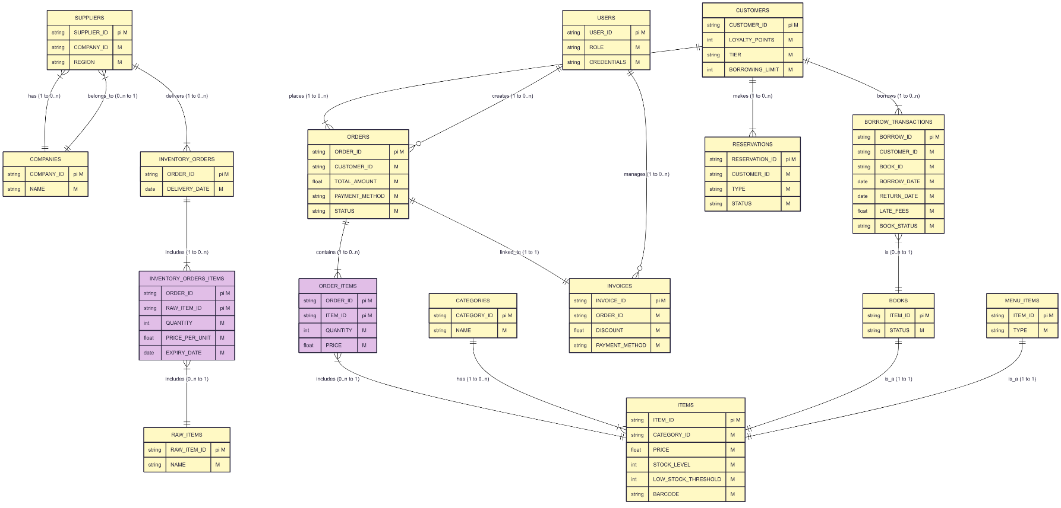
Figure 10: Conceptual Data Model
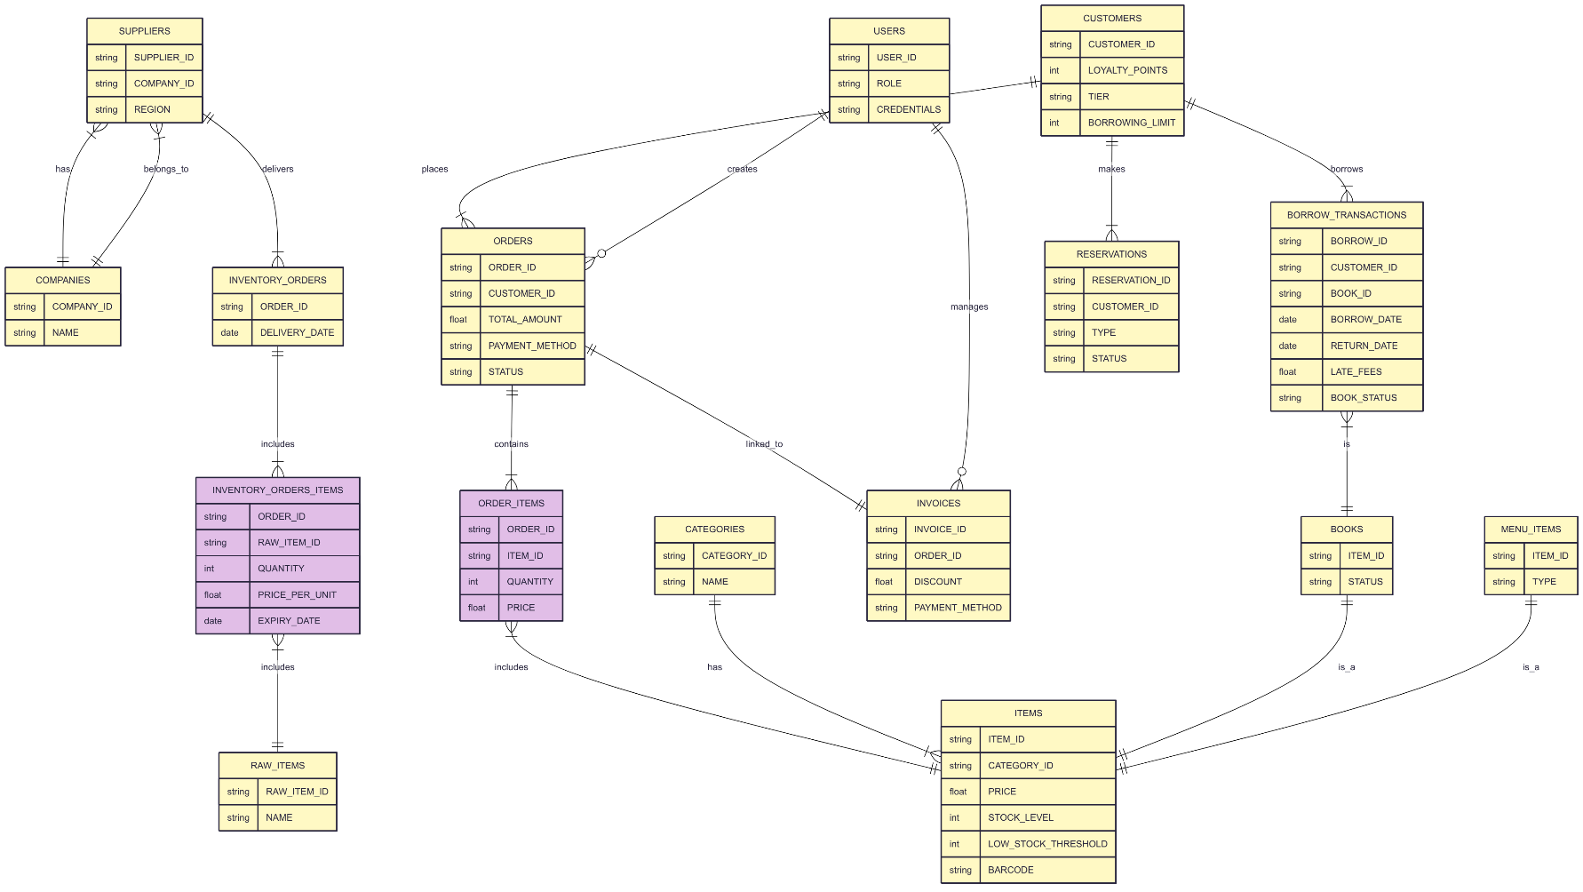
2.6 Logical Data Model :
Figure 11: Logical Data Model

3. Chapter 3 : DataBase Implementation

3.1 DBMS Advantages :
3.1.1 Functionality: MySQL is the best solution for corporations who have an enormous amount of data to handle and access.
3.1.2 Portability: It supports more than 100 hardware platforms and 20 networking protocols. You can also develop a completely featured MySQL application on any operating system without even knowing the underlying layers of that system. MySQL has the most user-friendly and easy to use features which is usable to any platform.
3.1.3 Quick recovery: If your system fails due to any technical issues, MySQL offers the quickest online backup and recovery features.
3.1.4 Speed and Performance: MySQL provides the best speed to access the database. With the highest level of performance.
(Reddy, The Advantages of MySQL Databases, n.d.)

3.2 Database Data Dictionary :

3.2.1 Table: roles
This table stores all the roles in the system.
Property | Description | Type | Length | Nature | Constraints
id | Role ID | Integer | - | Stable | Primary Key, Auto Increment
role_name | Role name | Varchar | 50 | Stable | Unique, Not Null

3.2.2 Table: users
This table contains the information of all system users.
Property | Description | Type | Length | Nature | Constraints
user_id | User ID | Integer | - | Stable | Primary Key, Auto Increment
username | Username | Varchar | 100 | Stable | Unique (with role), Not Null
password | User password | Varchar | 100 | Stable | Not Null
salt | Password salt | Varchar | 255 | Stable | Not Null
role | User role | Varchar | 50 | Stable | Foreign Key → roles(role_name), Not Null
created_at | Account creation date | Timestamp | - | Stable | Default CURRENT_TIMESTAMP

3.2.3 Table: customers
This table stores customer details.
Property | Description | Type | Length | Nature | Constraints
customer_id | Customer ID | Integer | - | Stable | Primary Key, Auto Increment
name | Customer name | Varchar | 100 | Stable | Unique, Not Null
phone | Contact number | Varchar | 20 | Movement | Nullable
loyalty_points | Loyalty points | Integer | - | Movement | Default 0
total_borrows | Total borrows | Integer | - | Movement | Default 0
created_at | Creation datetime | Datetime | - | Stable | Default CURRENT_TIMESTAMP

3.2.4 Table: categories
This table stores menu categories.
Property | Description | Type | Length | Nature | Constraints
category_id | Category ID | Integer | - | Stable | Primary Key, Auto Increment
name | Category name | Varchar | 50 | Stable | Unique, Not Null

3.2.5 Table: menu_items
This table stores all the items in the menu.
Property | Description | Type | Length | Nature | Constraints
item_id | Menu item ID | Integer | - | Stable | Primary Key, Auto Increment
name | Item name | Varchar | 100 | Stable | Unique, Not Null
category_id | Category ID | Integer | - | Stable | Foreign Key → categories(category_id)
price | Item price | Decimal | 10,2 | Movement | Not Null
stock | Item stock quantity | Integer | - | Movement | Default 0, Not Null
image_path | Image file path | Varchar | 255 | Stable | Nullable
created_by | User who added item | Integer | - | Stable | Foreign Key → users(user_id), Nullable

3.2.6 Table: orders
This table stores orders placed by customers.
Property | Description | Type | Length | Nature | Constraints
order_id | Order ID | Integer | - | Stable | Primary Key, Auto Increment
order_date | Date of order | Datetime | - | Stable | Default CURRENT_TIMESTAMP
user_id | Staff who took order | Integer | - | Stable | Foreign Key → users(user_id), Not Null
customer_id | Customer ID | Integer | - | Stable | Foreign Key → customers(customer_id), Nullable
total_amount | Total order amount | Decimal | 10,2 | Movement | Not Null
payment_method | Payment method | Enum | - | Stable | ('Cash','Card','Mobile'), Not Null
status | Order status | Enum | - | Movement | ('Paid','Cancelled'), Default 'Paid'

3.2.7 Table: order_details
This table stores details of each item in an order.
Property | Description | Type | Length | Nature | Constraints
order_detail_id | Order detail ID | Integer | - | Stable | Primary Key, Auto Increment
order_id | Order ID | Integer | - | Stable | Foreign Key → orders(order_id), Not Null
item_id | Menu item ID | Integer | - | Stable | Foreign Key → menu_items(item_id), Not Null
quantity | Item quantity | Integer | - | Movement | Default 1, Not Null
price | Item price | Decimal | 10,2 | Movement | Not Null
subtotal | Quantity × price | Decimal | 10,2 | Movement | Not Null

3.2.8 Table: books_inventory
This table stores all books available in inventory.
Property | Description | Type | Length | Nature | Constraints
book_id | Book ID | Integer | - | Stable | Primary Key, Auto Increment
title | Book title | Varchar | 150 | Stable | Unique, Not Null
author | Book author | Varchar | 100 | Stable | Nullable
genre | Book genre | Varchar | 50 | Stable | Nullable
isbn | Book ISBN | Varchar | 20 | Stable | Unique, Nullable
image_path | Cover image path | Varchar | 255 | Stable | Nullable
stock | Number of copies | Integer | - | Movement | Default 1, Not Null

3.2.9 Table: book_copies
This table stores individual copies of books.
Property | Description | Type | Length | Nature | Constraints
copy_id | Copy ID | Integer | - | Stable | Primary Key, Auto Increment
book_id | Book ID | Integer | - | Stable | Foreign Key → books_inventory(book_id), Not Null
status | Copy status | Enum | - | Movement | ('Available','Borrowed'), Default 'Available'

3.2.10 Table: book_borrow_transactions
This table stores book borrow/return transactions.
Property | Description | Type | Length | Nature | Constraints
borrow_id | Transaction ID | Integer | - | Stable | Primary Key, Auto Increment
customer_id | Customer ID | Integer | - | Stable | Foreign Key → customers(customer_id), Not Null
copy_id | Book copy ID | Integer | - | Stable | Foreign Key → book_copies(copy_id), Not Null
borrow_date | Date borrowed | Date | - | Movement | Not Null
due_date | Return due date | Date | - | Movement | Not Null
return_date | Date returned | Date | - | Movement | Nullable
late_fee | Late fee applied | Decimal | 10,2 | Movement | Default 0
status | Borrow status | Enum | - | Movement | ('Borrowed','Returned','Overdue'), Default 'Borrowed'

3.2.11 Table: suppliers
This table stores supplier details.
Property | Description | Type | Length | Nature | Constraints
supplier_id | Supplier ID | Integer | - | Stable | Primary Key, Auto Increment
name | Supplier name | Varchar | 150 | Stable | Unique, Not Null
contact_person | Contact person | Varchar | 100 | Stable | Unique, Nullable
phone | Phone number | Varchar | 20 | Movement | Nullable
email | Email address | Varchar | 100 | Movement | Nullable
address | Supplier address | Varchar | 255 | Movement | Nullable
created_at | Record created at | Datetime | - | Stable | Default CURRENT_TIMESTAMP

3.2.12 Table: supplied_items
This table stores items/books supplied by suppliers.
Property | Description | Type | Length | Nature | Constraints
supply_id | Supply ID | Integer | - | Stable | Primary Key, Auto Increment
supplier_id | Supplier ID | Integer | - | Stable | Foreign Key → suppliers(supplier_id), Not Null
item_id | Menu item ID | Integer | - | Stable | Foreign Key → menu_items(item_id), Nullable
book_id | Book ID | Integer | - | Stable | Foreign Key → books_inventory(book_id), Nullable
supply_price | Price per unit | Decimal | 10,2 | Movement | Not Null
quantity | Quantity supplied | Integer | - | Movement | Default 1, Not Null
last_delivery_date | Last delivery date | Date | - | Movement | Nullable
 | CHECK | - | - | - | item_id IS NOT NULL OR book_id IS NOT NULL

3.2.13 Table: daily_sales_summary
This table stores a summary of sales per day.
Property | Description | Type | Length | Nature | Constraints
summary_date | Date of summary | Date | - | Stable | Primary Key
total_sales | Total sales | Decimal | 10,2 | Movement | Default 0, Not Null
cash_sales | Cash payments | Decimal | 10,2 | Movement | Default 0, Not Null
card_sales | Card payments | Decimal | 10,2 | Movement | Default 0, Not Null
mobilepay_sales | Mobile payments | Decimal | 10,2 | Movement | Default 0, Not Null

3.2.14 Table: notifications
This table stores system notifications.
Property | Description | Type | Length | Nature | Constraints
notification_id | Notification ID | Integer | - | Stable | Primary Key, Auto Increment
title | Notification title | Varchar | 255 | Stable | Not Null
message | Notification message | Text | - | Movement | Not Null
type | Notification type | Varchar | 50 | Stable | Not Null
severity | Notification severity | Enum | - | Stable | ('danger','warning','info'), Default 'info'
sender_id | Sender user ID | Integer | - | Stable | Foreign Key → users(user_id), Nullable
data | Extra data JSON | JSON | - | Movement | Nullable
created_at | Notification date | Timestamp | - | Stable | Default CURRENT_TIMESTAMP

3.2.15 Table: notification_recipients
This table stores recipients of notifications.
Property | Description | Type | Length | Nature | Constraints
id | Record ID | Integer | - | Stable | Primary Key, Auto Increment
notification_id | Notification ID | Integer | - | Stable | Foreign Key → notifications(notification_id), Not Null
recipient_id | Recipient user ID | Integer | - | Stable | Foreign Key → users(user_id), Not Null
is_read | Read status | Boolean | - | Movement | Default FALSE
read_at | Read timestamp | Timestamp | - | Movement | Nullable
created_at | Record creation time | Timestamp | - | Stable | Default CURRENT_TIMESTAMP

3.3 SQL statements
1. Table: ROLES
create table ROLES
(
ID INTEGER not null,
ROLE_NAME VARCHAR2(50) not null unique,
constraint PK_ROLES primary key (ID)
);

2. Table: USERS
create table USERS
(
USER_ID INTEGER not null,
USERNAME VARCHAR2(100) not null,
PASSWORD VARCHAR2(100) not null,
SALT VARCHAR2(255) not null,
ROLE VARCHAR2(50) not null REFERENCES ROLES(ROLE_NAME) ON DELETE CASCADE,
CREATED_AT TIMESTAMP default CURRENT_TIMESTAMP,
constraint PK_USERS primary key (USER_ID),
constraint UNIQUE_USERNAME_ROLE unique (USERNAME, ROLE)
);

3. Table: CUSTOMERS
create table CUSTOMERS
(
CUSTOMER_ID INTEGER not null,
NAME VARCHAR2(100) not null unique,
PHONE VARCHAR2(20),
LOYALTY_POINTS INTEGER default 0 not null,
TOTAL_BORROWS INTEGER default 0 not null,
CREATED_AT DATETIME default CURRENT_TIMESTAMP,
constraint PK_CUSTOMERS primary key (CUSTOMER_ID)
);

4. Table: CATEGORIES
create table CATEGORIES
(
CATEGORY_ID INTEGER not null,
NAME VARCHAR2(50) not null unique,
constraint PK_CATEGORIES primary key (CATEGORY_ID)
);

5. Table: MENU_ITEMS
create table MENU_ITEMS
(
ITEM_ID INTEGER not null,
NAME VARCHAR2(100) not null unique,
CATEGORY_ID INTEGER REFERENCES CATEGORIES(CATEGORY_ID) ON DELETE SET NULL,
PRICE DECIMAL(10,2) not null,
STOCK INTEGER default 0 not null,
IMAGE_PATH VARCHAR2(255),
CREATED_BY INTEGER REFERENCES USERS(USER_ID) ON DELETE SET NULL,
constraint PK_MENU_ITEMS primary key (ITEM_ID)
);

6. Table: ORDERS
create table ORDERS
(
ORDER_ID INTEGER not null,
ORDER_DATE DATETIME default CURRENT_TIMESTAMP,
USER_ID INTEGER not null REFERENCES USERS(USER_ID) ON DELETE CASCADE,
CUSTOMER_ID INTEGER REFERENCES CUSTOMERS(CUSTOMER_ID) ON DELETE SET NULL,
TOTAL_AMOUNT DECIMAL(10,2) not null,
PAYMENT_METHOD VARCHAR2(10) not null,
STATUS VARCHAR2(10) default 'Paid' not null,
constraint PK_ORDERS primary key (ORDER_ID)
);

7. Table: ORDER_DETAILS
create table ORDER_DETAILS
(
ORDER_DETAIL_ID INTEGER not null,
ORDER_ID INTEGER not null REFERENCES ORDERS(ORDER_ID) ON DELETE CASCADE,
ITEM_ID INTEGER not null REFERENCES MENU_ITEMS(ITEM_ID) ON DELETE RESTRICT,
QUANTITY INTEGER default 1 not null,
PRICE DECIMAL(10,2) not null,
SUBTOTAL DECIMAL(10,2) not null,
constraint PK_ORDER_DETAILS primary key (ORDER_DETAIL_ID)
);

8. Table: BOOKS_INVENTORY
create table BOOKS_INVENTORY
(
BOOK_ID INTEGER not null,
TITLE VARCHAR2(150) not null unique,
AUTHOR VARCHAR2(100),
GENRE VARCHAR2(50),
ISBN VARCHAR2(20) unique,
IMAGE_PATH VARCHAR2(255),
STOCK INTEGER default 1 not null,
constraint PK_BOOKS_INVENTORY primary key (BOOK_ID)
);

9. Table: BOOK_COPIES
create table BOOK_COPIES
(
COPY_ID INTEGER not null,
BOOK_ID INTEGER not null REFERENCES BOOKS_INVENTORY(BOOK_ID) ON DELETE CASCADE,
STATUS VARCHAR2(10) default 'Available' not null,
constraint PK_BOOK_COPIES primary key (COPY_ID)
);

10. Table: BOOK_BORROW_TRANSACTIONS
create table BOOK_BORROW_TRANSACTIONS
(
BORROW_ID INTEGER not null,
CUSTOMER_ID INTEGER not null REFERENCES CUSTOMERS(CUSTOMER_ID) ON DELETE CASCADE,
COPY_ID INTEGER not null REFERENCES BOOK_COPIES(COPY_ID) ON DELETE CASCADE,
BORROW_DATE DATE not null,
DUE_DATE DATE not null,
RETURN_DATE DATE,
LATE_FEE DECIMAL(10,2) default 0,
STATUS VARCHAR2(10) default 'Borrowed' not null,
constraint PK_BOOK_BORROW primary key (BORROW_ID)
);

11. Table: SUPPLIERS create table SUPPLIERS
(
SUPPLIER_ID INTEGER not null,
NAME VARCHAR2(150) not null unique,
CONTACT_PERSON VARCHAR2(100) unique,
PHONE VARCHAR2(20),
EMAIL VARCHAR2(100),
ADDRESS VARCHAR2(255),
CREATED_AT DATETIME default CURRENT_TIMESTAMP,
constraint PK_SUPPLIERS primary key (SUPPLIER_ID)
);

12. Table: SUPPLIED_ITEMS
create table SUPPLIED_ITEMS
(
SUPPLY_ID INTEGER not null,
SUPPLIER_ID INTEGER not null REFERENCES SUPPLIERS(SUPPLIER_ID) ON DELETE CASCADE,
ITEM_ID INTEGER REFERENCES MENU_ITEMS(ITEM_ID) ON DELETE CASCADE,
BOOK_ID INTEGER REFERENCES BOOKS_INVENTORY(BOOK_ID) ON DELETE CASCADE,
SUPPLY_PRICE DECIMAL(10,2) not null,
QUANTITY INTEGER default 1 not null,
LAST_DELIVERY_DATE DATE,
constraint CK_ITEM_OR_BOOK check (ITEM_ID IS NOT NULL OR BOOK_ID IS NOT NULL),
constraint PK_SUPPLIED_ITEMS primary key (SUPPLY_ID)
);

13. Table: DAILY_SALES_SUMMARY
create table DAILY_SALES_SUMMARY
(
SUMMARY_DATE DATE not null,
TOTAL_SALES DECIMAL(10,2) default 0 not null,
CASH_SALES DECIMAL(10,2) default 0 not null,
CARD_SALES DECIMAL(10,2) default 0 not null,
MOBILEPAY_SALES DECIMAL(10,2) default 0 not null,
constraint PK_DAILY_SALES primary key (SUMMARY_DATE)
);

14. Table: NOTIFICATIONS
create table NOTIFICATIONS
(
NOTIFICATION_ID INTEGER not null,
TITLE VARCHAR2(255) not null,
MESSAGE VARCHAR2(4000) not null,
TYPE VARCHAR2(50) not null,
SEVERITY VARCHAR2(10) default 'info' not null,
SENDER_ID INTEGER REFERENCES USERS(USER_ID) ON DELETE SET NULL,
DATA CLOB,
CREATED_AT TIMESTAMP default CURRENT_TIMESTAMP,
constraint PK_NOTIFICATIONS primary key (NOTIFICATION_ID)
);

15. Table: NOTIFICATION_RECIPIENTS
create table NOTIFICATION_RECIPIENTS
(
ID INTEGER not null,
NOTIFICATION_ID INTEGER not null REFERENCES NOTIFICATIONS(NOTIFICATION_ID) ON DELETE CASCADE,
RECIPIENT_ID INTEGER not null REFERENCES USERS(USER_ID) ON DELETE CASCADE,
IS_READ BOOLEAN default FALSE,
READ_AT TIMESTAMP,
CREATED_AT TIMESTAMP default CURRENT_TIMESTAMP,
constraint PK_NOTIFICATION_RECIPIENTS primary key (ID),
constraint UNIQUE_NOTIFICATION_RECIPIENT unique (NOTIFICATION_ID, RECIPIENT_ID)
);

Views :
1. v_low_stock_items

CREATE OR REPLACE VIEW v_low_stock_items AS
SELECT item_id, name, category_id, stock, price
FROM menu_items
WHERE stock < 5
ORDER BY stock ASC;

2. v_unread_notifications

CREATE OR REPLACE VIEW v_unread_notifications AS
SELECT n.notification_id, n.title, n.message, n.type, n.severity, n.sender_id, n.data, n.created_at,
nr.recipient_id, nr.is_read, nr.read_at
FROM notifications n
JOIN notification_recipients nr ON n.notification_id = nr.notification_id
WHERE nr.is_read = FALSE;

3. v_notifications_summary

CREATE OR REPLACE VIEW v_notifications_summary AS
SELECT u.user_id, u.username, COUNT(nr.notification_id) AS unread_count
FROM users u
LEFT JOIN notification_recipients nr ON u.user_id = nr.recipient_id AND nr.is_read = FALSE
GROUP BY u.user_id, u.username;

4. v_sales_report

CREATE OR REPLACE VIEW v_sales_report AS
SELECT s.summary_date AS `Date`,
s.total_sales AS `Total Sales`,
s.cash_sales AS `Cash`,
s.card_sales AS `Card`,
s.mobilepay_sales AS `MobilePay`
FROM daily_sales_summary s
ORDER BY s.summary_date DESC;

5. v_books_analytics

CREATE OR REPLACE VIEW v_books_analytics AS
SELECT b.book_id,
b.title AS `Book Title`,
COUNT(bt.borrow_id) AS `Times Borrowed`,
SUM(CASE
WHEN bt.status = 'Overdue'
OR (bt.return_date IS NOT NULL AND bt.return_date > bt.due_date)
THEN 1 ELSE 0 END) AS `Overdue Count`,
SUM(CASE
WHEN bt.return_date IS NULL AND bt.status IN ('Borrowed','Overdue')
THEN 1 ELSE 0 END) AS `Currently Borrowed`,
b.stock AS `Current Stock`
FROM books_inventory b
LEFT JOIN book_copies bc ON b.book_id = bc.book_id
LEFT JOIN book_borrow_transactions bt ON bc.copy_id = bt.copy_id
GROUP BY b.book_id, b.title, b.stock;

6. v_supplier_performance

CREATE OR REPLACE VIEW v_supplier_performance AS
SELECT s.supplier_id,
s.name AS `Supplier Name`,
COUNT(si.supply_id) AS `Items Supplied`,
SUM(si.quantity) AS `Total Items`
FROM suppliers s
LEFT JOIN supplied_items si ON s.supplier_id = si.supplier_id
GROUP BY s.supplier_id, s.name
ORDER BY `Total Items` DESC;

Triggers :
1. after_book_insert

CREATE TRIGGER after_book_insert
AFTER INSERT ON books_inventory
FOR EACH ROW
BEGIN
CALL SyncBookCopies(NEW.book_id);
END;

2. after_book_update

CREATE TRIGGER after_book_update
AFTER UPDATE ON books_inventory
FOR EACH ROW
BEGIN
IF OLD.stock != NEW.stock THEN
CALL SyncBookCopies(NEW.book_id);
END IF;
END;

3. prevent_duplicate_borrow

CREATE TRIGGER prevent_duplicate_borrow
BEFORE INSERT ON book_borrow_transactions
FOR EACH ROW
BEGIN
DECLARE already_out INT DEFAULT 0;
SELECT COUNT(*) INTO already_out
FROM book_borrow_transactions t
JOIN book_copies c ON t.copy_id = c.copy_id
WHERE t.customer_id = NEW.customer_id
AND c.book_id = (SELECT book_id FROM book_copies WHERE copy_id = NEW.copy_id)
AND t.status IN ('Borrowed','Overdue');
IF already_out > 0 THEN
SIGNAL SQLSTATE '45000'
SET MESSAGE_TEXT = 'Customer already has an unreturned copy of this title or have read it before.';
END IF;
END;

4. ensure_copy_available

CREATE TRIGGER ensure_copy_available
BEFORE INSERT ON book_borrow_transactions
FOR EACH ROW
BEGIN
DECLARE curr_status ENUM('Available','Borrowed');
SELECT status INTO curr_status FROM book_copies WHERE copy_id = NEW.copy_id FOR UPDATE;
IF curr_status IS NULL THEN
SIGNAL SQLSTATE '45000' SET MESSAGE_TEXT = 'Book copy does not exist.';
END IF;
IF curr_status <> 'Available' THEN
SIGNAL SQLSTATE '45000' SET MESSAGE_TEXT = 'Book copy is not available for borrowing.';
END IF;
END;

5. set_copy_borrowed

CREATE TRIGGER set_copy_borrowed
AFTER INSERT ON book_borrow_transactions
FOR EACH ROW
BEGIN
UPDATE book_copies SET status = 'Borrowed' WHERE copy_id = NEW.copy_id;
END;

6. update_copy_on_return

CREATE TRIGGER update_copy_on_return
AFTER UPDATE ON book_borrow_transactions
FOR EACH ROW
BEGIN
IF NEW.return_date IS NOT NULL AND OLD.return_date IS NULL THEN
UPDATE book_copies SET status = 'Available' WHERE copy_id = NEW.copy_id;
IF NEW.status = 'Borrowed' THEN
UPDATE book_borrow_transactions SET status = 'Returned' WHERE borrow_id = NEW.borrow_id;
END IF;
END IF;
IF NEW.status = 'Returned' AND OLD.status <> 'Returned' AND NEW.return_date IS NULL THEN
UPDATE book_borrow_transactions SET return_date = CURDATE() WHERE borrow_id = NEW.borrow_id;
END IF;
END;

7. after_order_insert

CREATE TRIGGER after_order_insert
AFTER INSERT ON orders
FOR EACH ROW
BEGIN
INSERT INTO daily_sales_summary(summary_date,total_sales,cash_sales,card_sales,mobilepay_sales)
VALUES (DATE(NEW.order_date),NEW.total_amount,
IF(NEW.payment_method='Cash',NEW.total_amount,0),
IF(NEW.payment_method='Card',NEW.total_amount,0),
IF(NEW.payment_method='Mobile',NEW.total_amount,0))
ON DUPLICATE KEY UPDATE
total_sales = total_sales + NEW.total_amount,
cash_sales = cash_sales + IF(NEW.payment_method='Cash',NEW.total_amount,0),
card_sales = card_sales + IF(NEW.payment_method='Card',NEW.total_amount,0),
mobilepay_sales = mobilepay_sales + IF(NEW.payment_method='Mobile',NEW.total_amount,0);

IF NEW.customer_id IS NOT NULL AND NEW.status = 'Paid' THEN
UPDATE customers
SET loyalty_points = loyalty_points + FLOOR(NEW.total_amount / 10)
WHERE customer_id = NEW.customer_id;
END IF;
END;

8. after_order_detail_insert

CREATE TRIGGER after_order_detail_insert
AFTER INSERT ON order_details
FOR EACH ROW
BEGIN
UPDATE menu_items SET stock = stock - NEW.quantity WHERE item_id = NEW.item_id;
END;

9. after_supply_insert

CREATE TRIGGER after_supply_insert
AFTER INSERT ON supplied_items
FOR EACH ROW
BEGIN
UPDATE menu_items SET stock = stock + NEW.quantity WHERE item_id = NEW.item_id;
END;

10. trg_update_total_borrows

CREATE TRIGGER trg_update_total_borrows
AFTER INSERT ON book_borrow_transactions
FOR EACH ROW
BEGIN
UPDATE customers SET total_borrows = total_borrows + 1 WHERE customer_id = NEW.customer_id;
END;

11. trg_new_menu_item_notification

CREATE TRIGGER trg_new_menu_item_notification
AFTER INSERT ON menu_items
FOR EACH ROW
BEGIN
DECLARE notif_id INT;
INSERT INTO notifications(title,message,type,severity,sender_id,data)
VALUES ('New Menu Item Added', CONCAT('Menu item ',NEW.name,' has been added.'),'Menu','info',NULL,
JSON_OBJECT('item_id',NEW.item_id,'name',NEW.name));
SET notif_id = LAST_INSERT_ID();
INSERT INTO notification_recipients(notification_id,recipient_id)
SELECT notif_id, u.user_id FROM users u WHERE u.role IN ('admin','staff');
END;

12. trg_low_stock_notification

CREATE TRIGGER trg_low_stock_notification
AFTER UPDATE ON menu_items
FOR EACH ROW
BEGIN
DECLARE notif_id INT;
IF NEW.stock < 5 AND NEW.stock <> OLD.stock THEN
INSERT INTO notifications(title,message,type,severity,sender_id,data)
VALUES ('Low Stock Alert', CONCAT(NEW.name,' stock is low (',NEW.stock,' left). Please restock.'),
'Stock','danger',NULL,JSON_OBJECT('item_id',NEW.item_id,'current_stock',NEW.stock));
SET notif_id = LAST_INSERT_ID();
INSERT INTO notification_recipients(notification_id,recipient_id)
SELECT notif_id, u.user_id FROM users u WHERE u.role IN ('admin','staff');
END IF;
END;

13. trg_new_item_low_stock_notification

CREATE TRIGGER trg_new_item_low_stock_notification
AFTER INSERT ON menu_items
FOR EACH ROW
BEGIN
DECLARE notif_id INT;
IF NEW.stock < 5 THEN
INSERT INTO notifications (title, message, type, severity, sender_id, data)
VALUES (
'New Item with Low Stock',
CONCAT(NEW.name, ' was added with low stock (', NEW.stock, ' left). Please restock.'),
'Stock',
'danger',
NULL,
JSON_OBJECT('item_id', NEW.item_id, 'current_stock', NEW.stock)
);
SET notif_id = LAST_INSERT_ID();
INSERT INTO notification_recipients (notification_id, recipient_id)
SELECT notif_id, user_id FROM users WHERE role IN ('admin', 'staff');
END IF;
END;

14. trg_new_book_notification

CREATE TRIGGER trg_new_book_notification
AFTER INSERT ON books_inventory
FOR EACH ROW
BEGIN
DECLARE notif_id INT;
INSERT INTO notifications (title, message, type, severity, sender_id, data)
VALUES (
'New Book Arrival',
CONCAT(NEW.title, ' is now available in inventory.'),
'Book',
'info',
NULL,
JSON_OBJECT('book_id', NEW.book_id, 'title', NEW.title)
);
SET notif_id = LAST_INSERT_ID();
INSERT INTO notification_recipients (notification_id, recipient_id)
SELECT notif_id, user_id FROM users WHERE role IN ('admin', 'staff');
END;

15. trg_book_borrow_notification

CREATE TRIGGER trg_book_borrow_notification
AFTER INSERT ON book_borrow_transactions
FOR EACH ROW
BEGIN
DECLARE notif_id INT;
INSERT INTO notifications(title,message,type,severity,sender_id,data)
VALUES ('Book Borrowed', CONCAT('Customer ID ',NEW.customer_id,' borrowed book copy ID ',NEW.copy_id),
'Book','info',NULL,JSON_OBJECT('borrow_id',NEW.borrow_id,'customer_id',NEW.customer_id,'copy_id',NEW.copy_id));
SET notif_id = LAST_INSERT_ID();
INSERT INTO notification_recipients(notification_id,recipient_id)
SELECT notif_id, user_id FROM users WHERE role IN ('admin','staff');
END;

16. trg_order_notification

CREATE TRIGGER trg_order_notification
AFTER INSERT ON orders
FOR EACH ROW
BEGIN
DECLARE notif_id INT;
INSERT INTO notifications (title, message, type, severity, sender_id, data)
VALUES (
'New Order Placed',
CONCAT('Order #', NEW.order_id, ' has been placed by customer ID ', NEW.customer_id),
'Order',
'info',
NEW.user_id,
JSON_OBJECT('order_id', NEW.order_id, 'customer_id', NEW.customer_id, 'total', NEW.total_amount)
);
SET notif_id = LAST_INSERT_ID();
INSERT INTO notification_recipients (notification_id, recipient_id)
SELECT notif_id, user_id FROM users WHERE role IN ('admin', 'staff');
END;

17. trg_supplied_items_check

CREATE TRIGGER trg_supplied_items_check
BEFORE INSERT ON supplied_items
FOR EACH ROW
BEGIN
IF NEW.item_id IS NULL AND NEW.book_id IS NULL THEN
SIGNAL SQLSTATE '45000'
SET MESSAGE_TEXT = 'Either item_id or book_id must be provided.';
END IF;
END;

18. trg_supplied_items_check_upd

CREATE TRIGGER trg_supplied_items_check_upd
BEFORE UPDATE ON supplied_items
FOR EACH ROW
BEGIN
IF NEW.item_id IS NULL AND NEW.book_id IS NULL THEN
SIGNAL SQLSTATE '45000'
SET MESSAGE_TEXT = 'Either item_id or book_id must be provided.';
END IF;
END;

19. trg_all_books_borrowed

CREATE TRIGGER trg_all_books_borrowed
AFTER UPDATE ON book_copies
FOR EACH ROW
BEGIN
DECLARE available_count INT;
DECLARE book_title VARCHAR(150);
DECLARE notif_id INT;

IF OLD.status = 'Available' AND NEW.status = 'Borrowed' THEN
SELECT COUNT(*) INTO available_count
FROM book_copies
WHERE book_id = NEW.book_id AND status = 'Available';

IF available_count = 0 THEN
SELECT title INTO book_title FROM books_inventory WHERE book_id = NEW.book_id;
INSERT INTO notifications (title, message, type, severity, sender_id, data)
VALUES (
'Book Out of Stock',
CONCAT('All copies of "', book_title, '" are currently borrowed.'),
'Book',
'warning',
NULL,
JSON_OBJECT('book_id', NEW.book_id, 'title', book_title)
);
SET notif_id = LAST_INSERT_ID();
INSERT INTO notification_recipients (notification_id, recipient_id)
SELECT notif_id, user_id FROM users WHERE role IN ('admin', 'staff');
END IF;
END IF;
END;

20. trg_customer_returned_book_notification

CREATE TRIGGER trg_customer_returned_book_notification
AFTER UPDATE ON book_borrow_transactions
FOR EACH ROW
BEGIN
DECLARE book_title VARCHAR(150);
DECLARE notif_title VARCHAR(100);
DECLARE notif_message TEXT;
DECLARE notif_severity VARCHAR(20);

IF NEW.return_date IS NOT NULL AND OLD.return_date IS NULL THEN
SELECT bi.title INTO book_title
FROM book_copies bc
JOIN books_inventory bi ON bc.book_id = bi.book_id
WHERE bc.copy_id = NEW.copy_id;

IF NEW.return_date > NEW.due_date THEN
SET notif_title = 'Overdue Book Returned';
SET notif_message = CONCAT('Customer ID ', NEW.customer_id, ' returned an overdue copy of "', book_title, '" (Copy ID: ', NEW.copy_id, ').');
SET notif_severity = 'info';
ELSE
SET notif_title = 'Book Returned';
SET notif_message = CONCAT('Customer ID ', NEW.customer_id, ' returned a copy of "', book_title, '" (Copy ID: ', NEW.copy_id, ').');
SET notif_severity = 'info';
END IF;

INSERT INTO notifications (title, message, type, severity, sender_id, data)
VALUES (
notif_title,
notif_message,
'Book',
notif_severity,
NULL,
JSON_OBJECT('customer_id', NEW.customer_id, 'copy_id', NEW.copy_id)
);

INSERT INTO notification_recipients (notification_id, recipient_id)
SELECT LAST_INSERT_ID(), user_id FROM users WHERE role IN ('admin', 'staff');
END IF;
END;

21. trg_book_available_notification

CREATE TRIGGER trg_book_available_notification
AFTER UPDATE ON book_copies
FOR EACH ROW
BEGIN
DECLARE book_title VARCHAR(150);
DECLARE notif_id INT;

IF OLD.status = 'Borrowed' AND NEW.status = 'Available' THEN
SELECT title INTO book_title FROM books_inventory WHERE book_id = NEW.book_id;
INSERT INTO notifications (title, message, type, severity, sender_id, data)
VALUES (
'Book Now Available',
CONCAT('A copy of "', book_title, '" is now available again.'),
'Book',
'info',
NULL,
JSON_OBJECT('book_id', NEW.book_id, 'copy_id', NEW.copy_id)
);

SET notif_id = LAST_INSERT_ID();
INSERT INTO notification_recipients (notification_id, recipient_id)
SELECT notif_id, user_id FROM users WHERE role IN ('admin', 'staff');
END IF;
END;

22. after_supply_insert_books

CREATE TRIGGER after_supply_insert_books
AFTER INSERT ON supplied_items
FOR EACH ROW
BEGIN
IF NEW.book_id IS NOT NULL THEN
UPDATE books_inventory
SET stock = stock + NEW.quantity
WHERE book_id = NEW.book_id;
CALL SyncBookCopies(NEW.book_id);
END IF;
END;

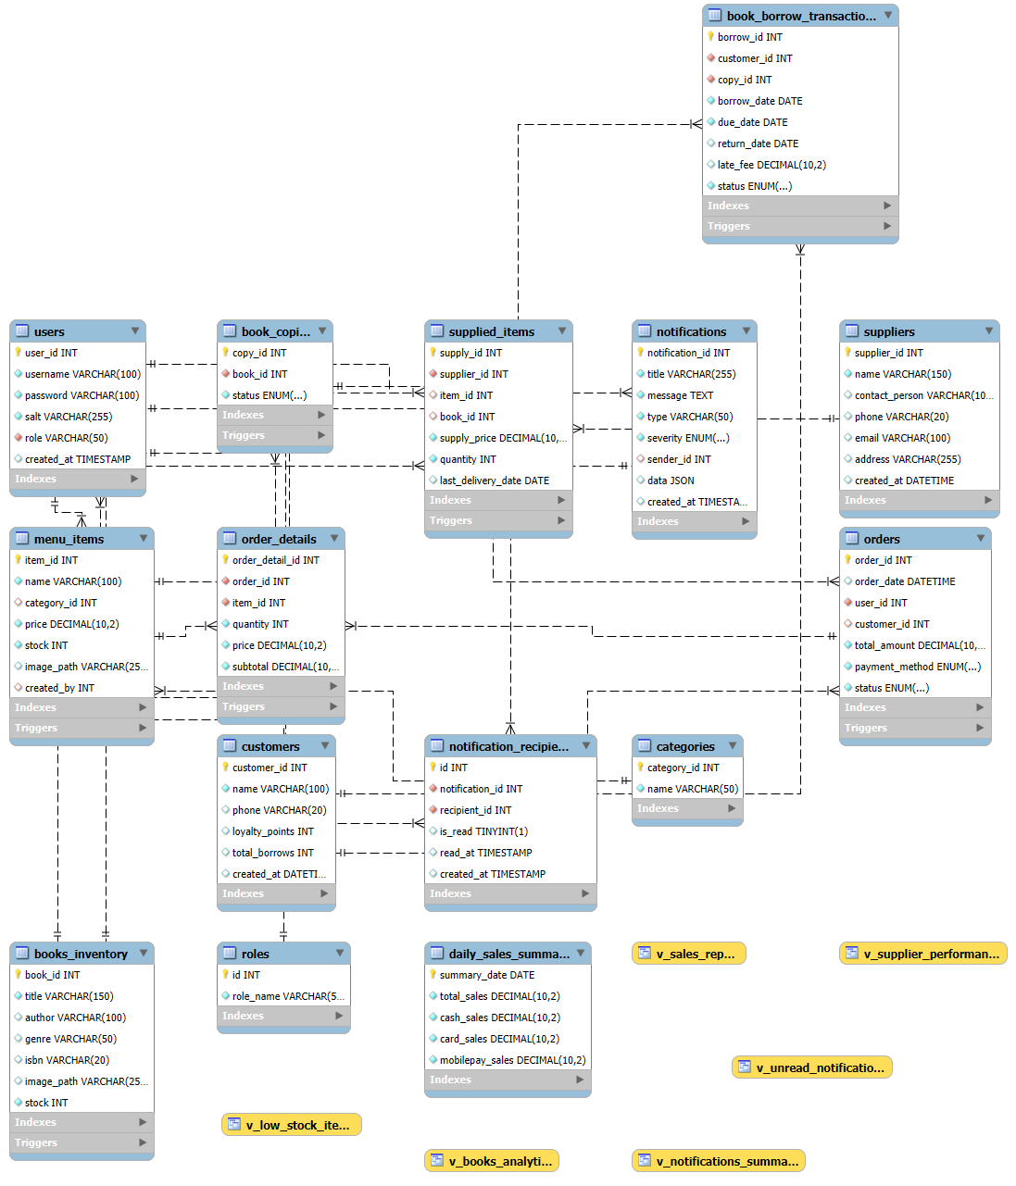
Figure 12: Physical Data Model

4. Chapter 4: Software Implementation

4.1 Database Connection String :
DriverManager.registerDriver(new oracle.jdbc.driver.OracleDriver());
String URL = "jdbc:oracle:thin:@localhost:1521:XE";
String USER = "USER";
String PASS = "PASS";
Connection conn = DriverManager.getConnection(URL, USER, PASS);
This connects user USER with password PASS to a database with SID XE through port 1521 of host <local host> , using the Thin driver.

4.2 Main Programming Tasks :

4.2.1 Admin Functions
Admins have full system access. Tasks include :

User Management
a) Start.
b) Display user management panel.
c) Retrieve list of all users.
d) Respond to clicks on “Add User” → open a form to enter details.
e) Respond to clicks on “Edit User” → populate form with selected user info.
f) Respond to clicks on “Delete User” → remove selected user after confirmation.
g) Respond to role change requests → update user role (Admin / Staff).

Menu & Book Management
a) Start.
b) Display menu & book management panel.
c) Retrieve list of all menu items and books.
d) Respond to clicks on “Add Item/Book” → open form to input new details.
e) Respond to clicks on “Edit Item/Book” → populate form with existing details.
f) Respond to clicks on “Delete Item/Book” → remove selected item/book after confirmation.
g) Update stock levels, prices.

Analytics, Reports & Notifications

a) Start.
b) Display analytics/reports panel with 4 tabs.
c) Respond to clicks on “Sales Reports” → generate sales data and display in table/chart.
d) Respond to clicks on “Books Analytics” → retrieve borrowing/reading data and display statistics.
e) Respond to clicks on “Supplier Performance” → compute inventory turnover, delivery history, and supplier efficiency.
f) Respond to clicks on “Notifications” → open notifications panel showing:
- Low-stock alerts.
- New menu items/books orders.
- Messages or alerts from staff.

4.2.2 Staff (Cashier) Functions

Order Processing
a) Start.
b) Display the order processing panel (left: menu items, right: current order table).
c) Populate menu items grid from the database using menuItemDAO.findAllByStock().
d) Respond to clicks on an item card → call addItemToOrder() and update order table & total.
e) If item exists in order → increment quantity; else → add new row.
f) Show updated total in totalLabel.
g) Respond to button clicks :
Submit Order → validate customer, create Order object, insert into DB with orderDAO.insert(), print invoice, clear order.
- Clear Order → remove all order items and reset total.
- Delete Item → remove selected row from table and update total.
- Print Invoice → show invoice preview and send to print.

Customer Service
a) Start.
b) Display customer service panel with :

- Search bar + filter/clear buttons.
- Customer table (ID, Name, Phone, Points, Tier, Total Borrows, Created At).
- Action buttons (Add, Edit, Delete).
c) Populate table from DB (customers table) with loyalty points, tier (Bronze/Silver/Gold/Diamond), and total borrows.
d) Respond to clicks :
- Filter / Search → query DB by name or phone, update table.
- Clear → reset search, reload all customers.
- Add → open CustomerDialog, save new customer, refresh table.
- Edit → open dialog with selected customer’s info, update record, refresh table.
- Delete → confirm with CustomConfirmDialog, remove from DB, refresh table.

Book Borrowing
a) Start.
b) Display book borrowing panel split into :
- Left panel: grid of available books (with title, image, borrow button).
- Right panel: customer selector + borrow transactions table (Borrow ID, Customer, Book, Borrow Date, Due Date, Return Date, Late Fee).
c) Load customers from DB and populate customerCombo.
d) Load available books from DB and render as cards with “Borrow” button.
e) Respond to clicks :
- Borrow Book → check for available copy → insert borrow transaction (borrow_date, due_date) → update copy status to “Borrowed” → refresh books + table.
- Edit Transaction → open BookReturn dialog if transaction not yet returned → mark as returned, calculate late fee, update DB → refresh table and available books.
- Delete Transaction → confirm → delete borrow record from DB → reset book copy to “Available” → refresh table and books.

Alerts Handling
a) Start.
b) Display Alerts & Notifications panel with :
- Filter dropdown (All / danger / info).
- Buttons: “Notify Admin”, “Mark Selected as Read”, “Refresh Alerts”.
- Notification list with custom renderer (icons + styled display).
c) On load → fetch unread notifications for logged-in staff from DB via NotificationDAO.
- If severity filter is applied → only retrieve matching severity.
- Populate JList with alert items (icon + [type] title – message).
- Show “No new alerts” if empty.
d) Respond to actions :
- Notify Admin → open NotifyAdminDialog → send custom notification to admins → reload list.
- Mark Selected as Read → update DB to mark chosen alert as read → reload list.
- Refresh Alerts → reload notifications from DB and re-render.
- Double-click on list item → deselect the alert (UI behavior).

4.3 GUI (Graphical user Interface) :

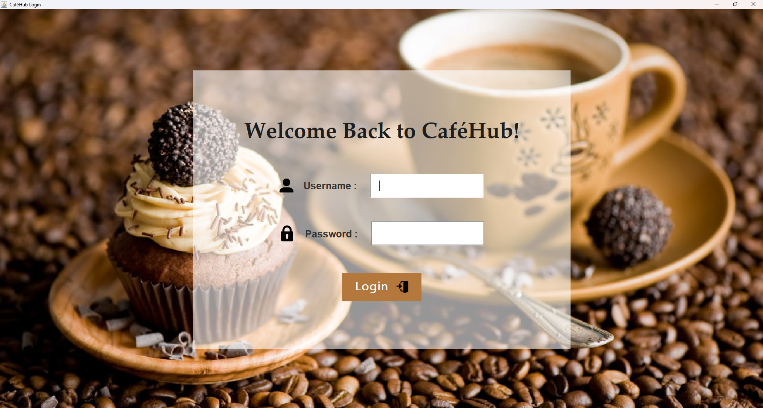
Figure 13: Login Page
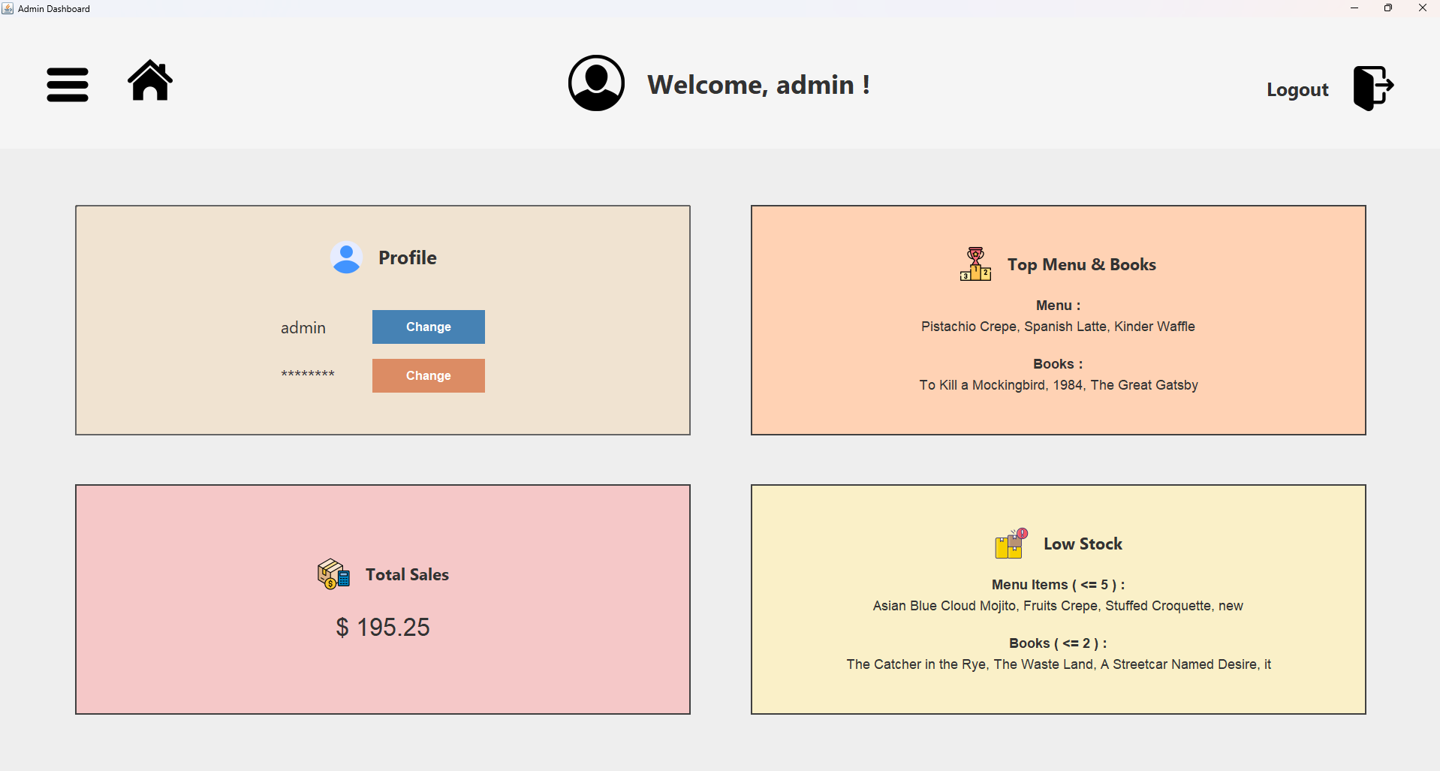
Figure 14: Admin Account Managing

Figure 15: Users Managing
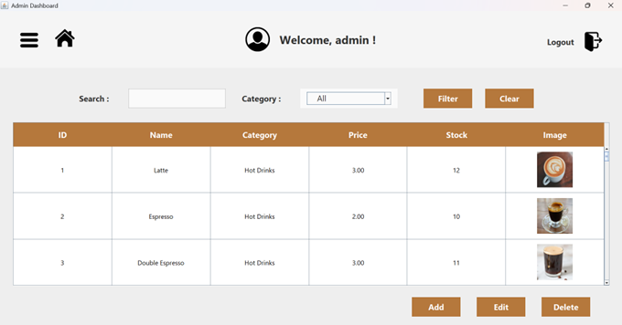
Figure 16: Menu Managing

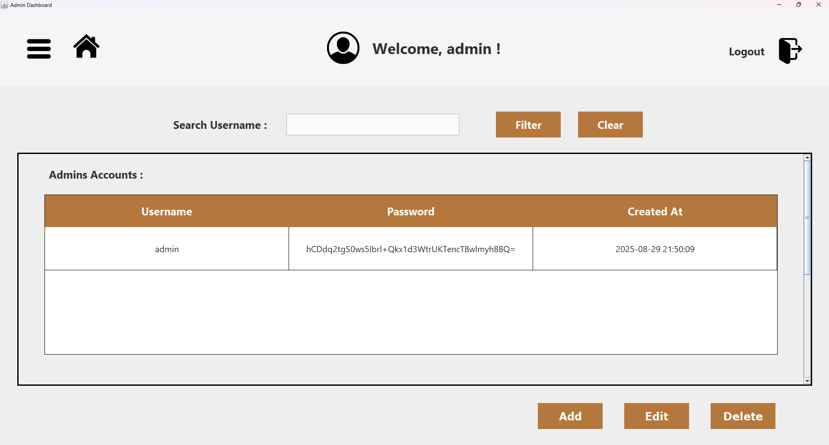

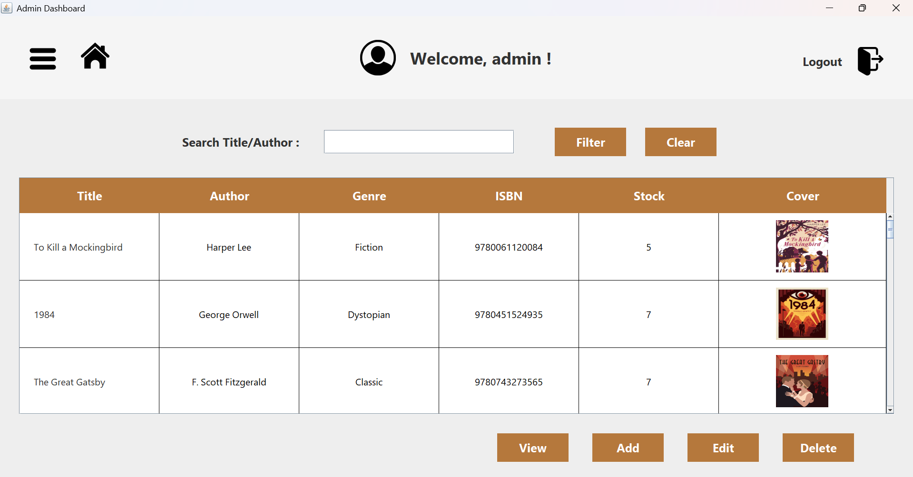
Figure 17: Book Managing
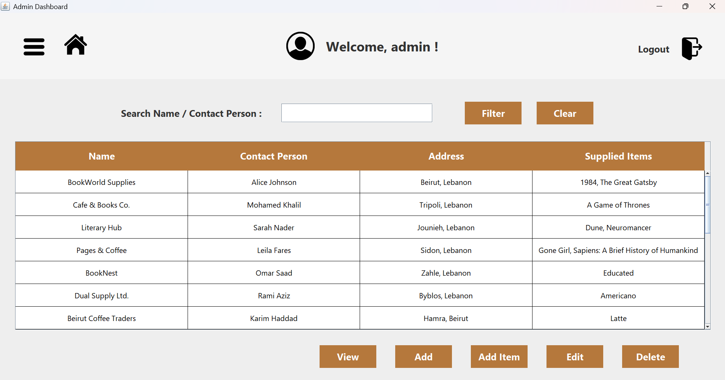
Figure 18: Supplier Management

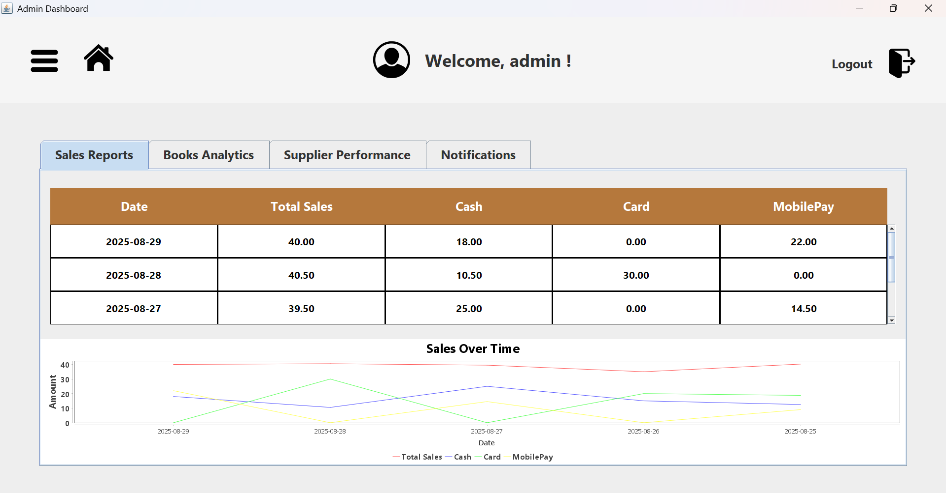
Figure 19: Analytics and Reports
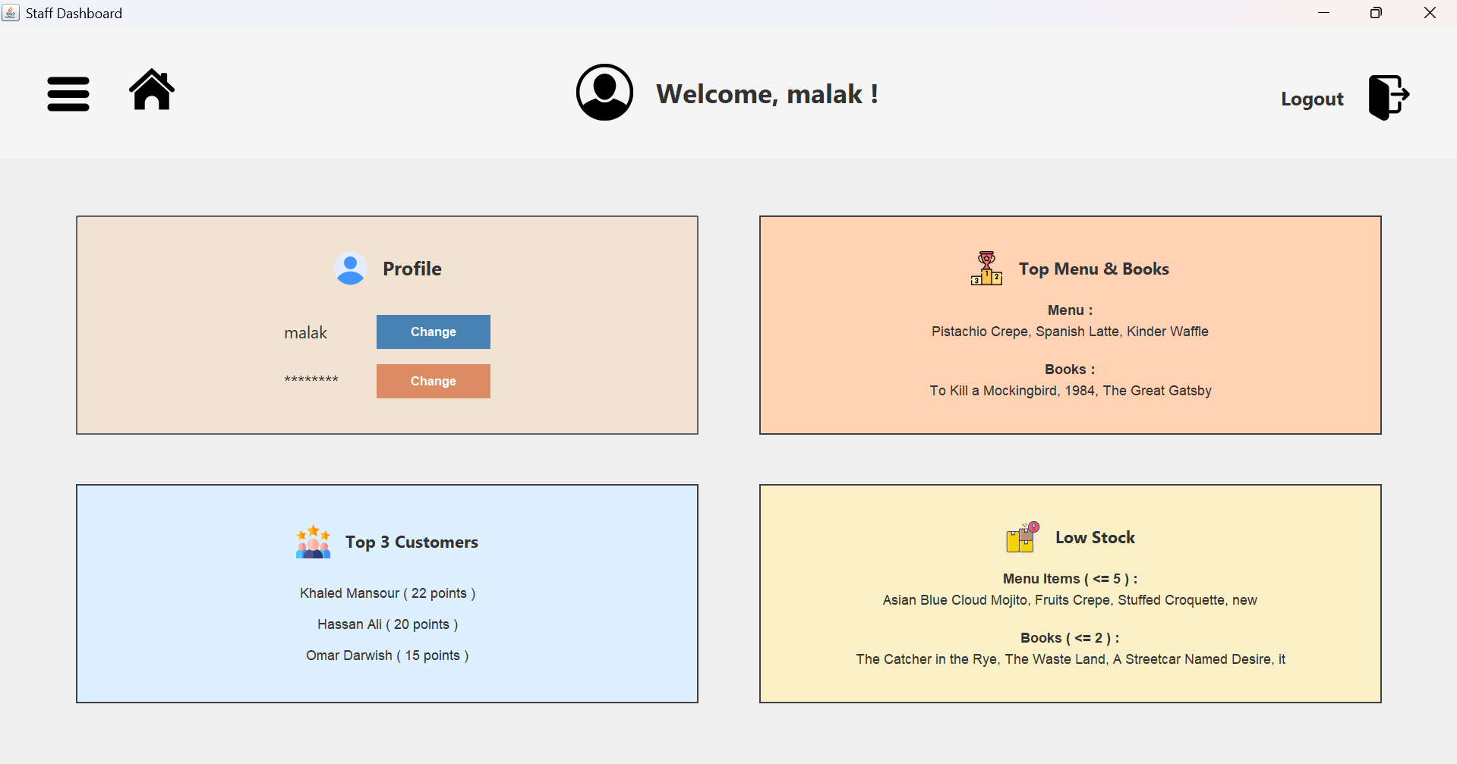
Figure 20: Staff Account Managing

Figure 21: Order Processing

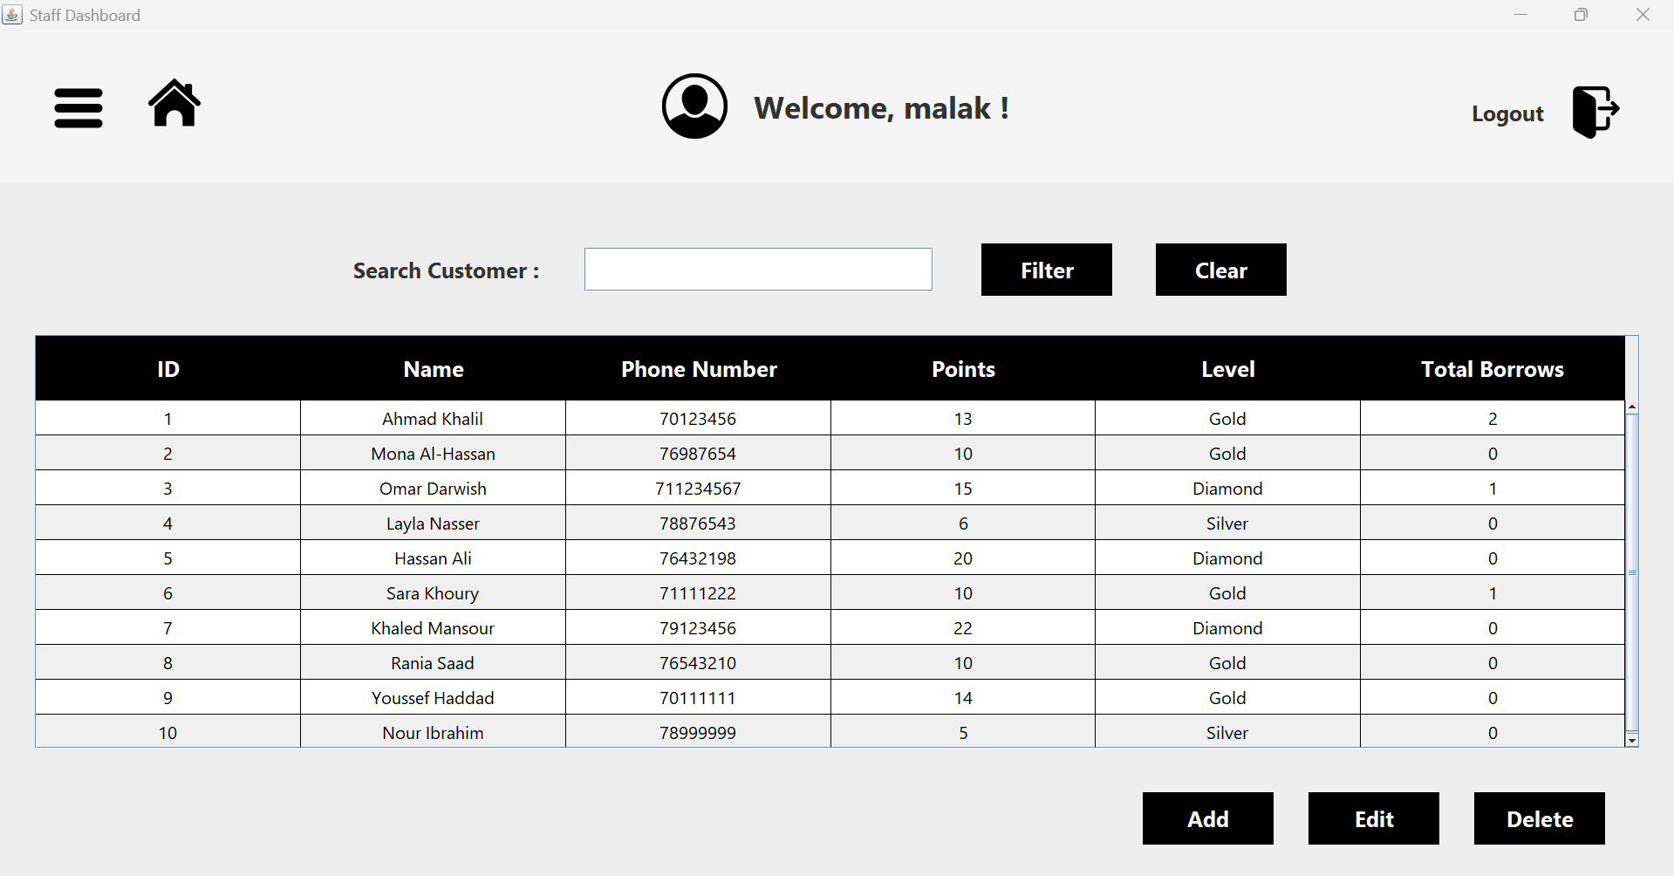

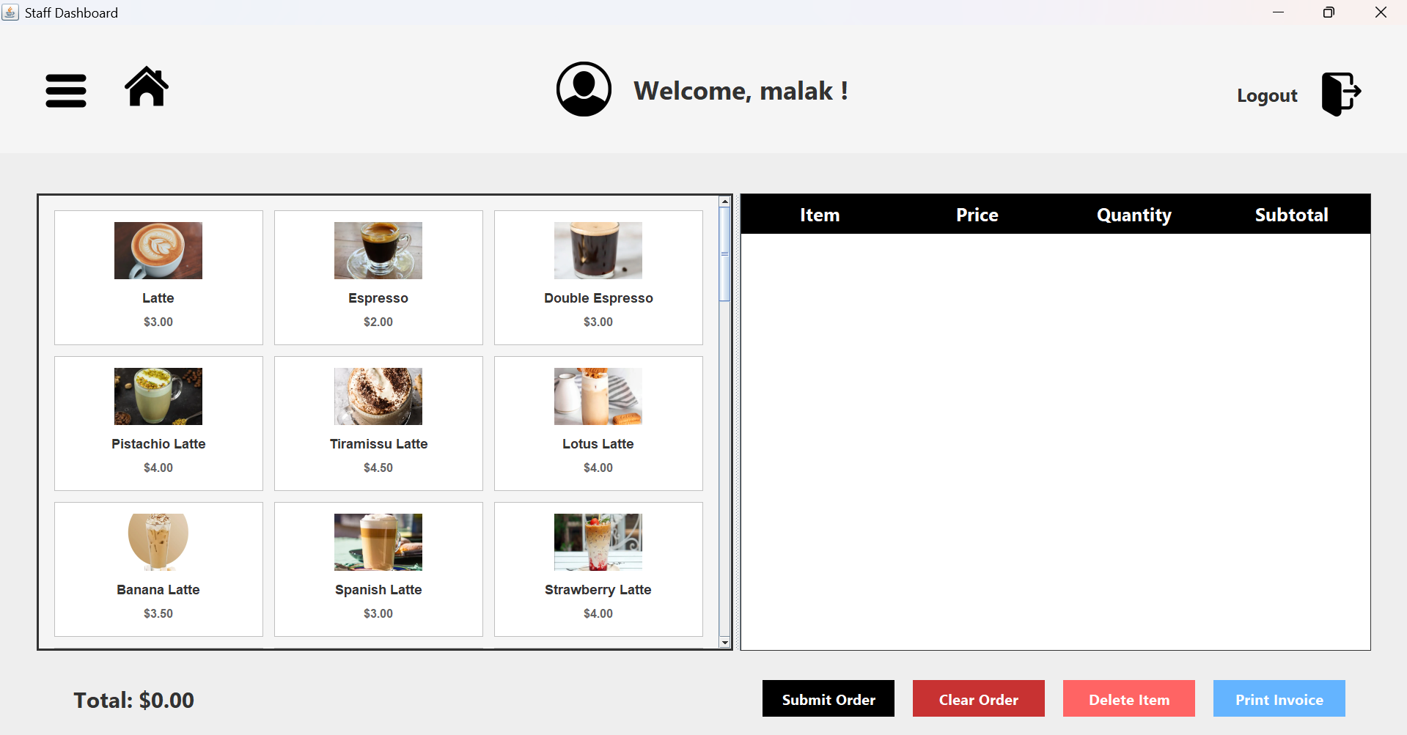

Figure 22: Customer Managing

Figure 23: Book Borrowing
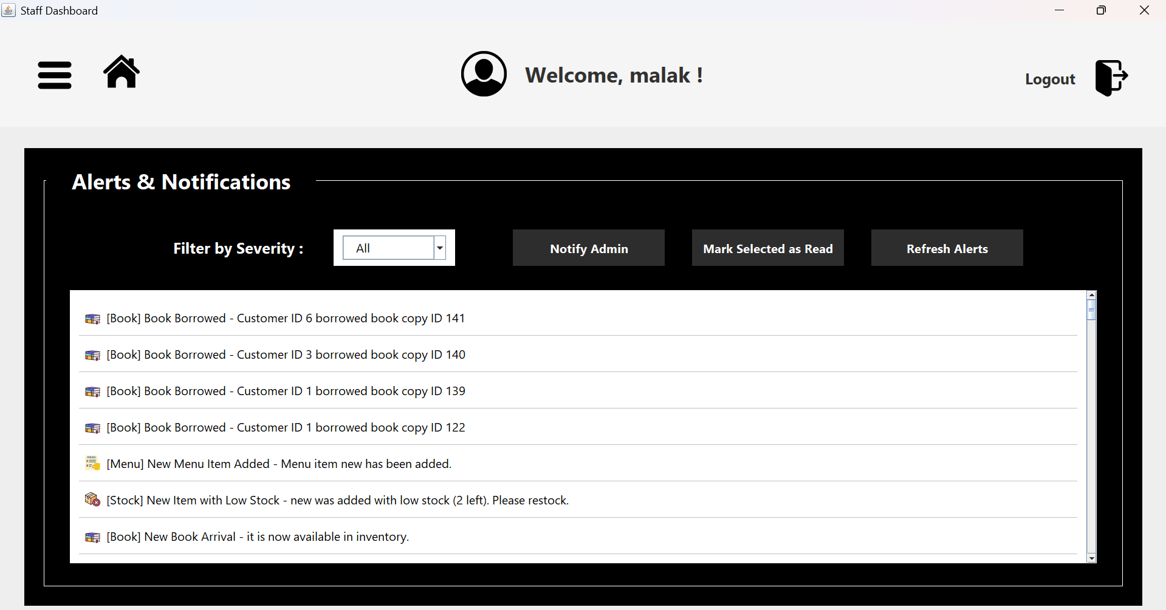
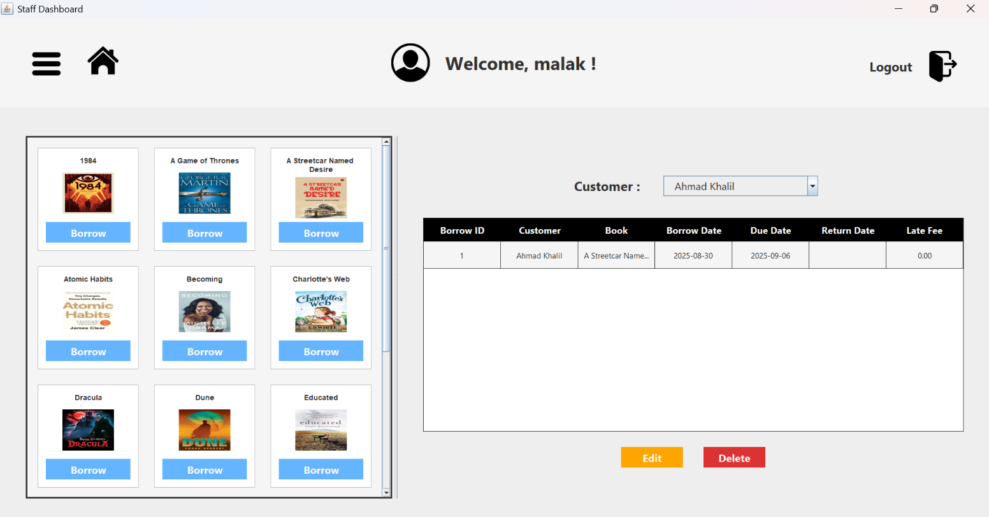
Figure 24: Alert Handling

4.4 JAVA Documentation

4.4.1 Class Account
Constructor | Description
Account(int id, String password) | Creates a new account with the given ID and password.

Modifier & Type | Method | Brief Description
static void | changePassword  (int id, String password) | Updates the password for a given account.
static void | createAccount  (int id) | Creates a new account (Admin task: Add User).
static String | getPassword (int id) | Returns the password for the account.
static boolean | isAvailable(int id) | Checks if the account exists.
static void | remove(int id) | Deletes the account (Admin task: Delete User).

4.4.2 Class Customer
Constructor | Description
Customer(int id, String name) | Creates a new customer record.

Modifier & Type | Method | Brief Description
static void | addCustomer  (int id, String name) | Adds a new customer (Staff task: Add Customer).
static void | updateCustomer  (int id, String newName) | Updates customer details (Staff task: Edit Customer).
static void | removeCustomer  (int id) | Deletes a customer (Staff task: Delete Customer).
static int | getLoyaltyPoints  (int id) | Returns current loyalty points (Staff task: display table).
static void | updateLoyaltyPoints  (int id, int points) | Adds or subtracts loyalty points (Staff task: update).

4.4.3 Class MenuItem
Constructor | Description
MenuItem(int id, String name, double price) | Creates a menu item with ID, name, and price.

Modifier & Type | Method | Brief Description
static void | addItem  (int id, String name, double price) | Adds item (Admin task: Add).
static void | updateItemPrice  (int id, double newPrice) | Updates price or stock (Admin task: Edit).
static void | removeItem  (int id) | Deletes item (Admin task: Delete).
static boolean | isAvailable  (int id) | Checks stock (Staff task: populate menu grid).

4.4.4 Class Supplier
Constructor | Description
Supplier (int id, String name) | Creates a new supplier record.

Modifier & Type | Method | Brief Description
static void | addSupplier  (int id, String name) | Adds supplier (Admin task: Add Supplier).
static void | updateSupplier  (int id, String newName) | Updates supplier info (Admin task: Edit Supplier).
static void | recordSupply  (int supplierId, int itemId, int quantity, double price) | Records supply transaction.
static void | removeSupplier (int id) | Deletes supplier (Admin task: Delete Supplier).

4.4.5 Class Order
Constructor | Description
Order (int orderId, int customerId) | Creates a new order for a customer.

Modifier & Type | Method | Brief Description
static void | createOrder  (int orderId, int customerId) | Creates a new order (Staff task: Submit Order).
static void | addItemToOrder  (int orderId, int itemId, int quantity) | Adds/increments item in order table.
static void | applyDiscount  (int orderId, double discount) | Applies discount to order.
static void | processPayment  (int orderId, double amount) | Finalizes payment and prints invoice.
static void | cancelOrder (int orderId) | Clears order table (Staff task: Clear Order).

4.4.6 Class Book
Constructor | Description
Book(int id, String title) | Creates a book record.

Modifier & Type | Method | Brief Description
static void | addBook (int id, String title) | Adds a new book (Admin task: Add Book).
static void | updateBook  (int id, String newTitle) | Updates book info (Admin task: Edit Book).
static void | removeBook (int id) | Deletes a book (Admin task: Delete Book).
static boolean | isAvailable (int id) | Checks if book copy is available (Staff task).

4.4.7 Class BorrowTransaction
Constructor | Description
BorrowTransaction (int transactionId, int bookId, int customerId) | Creates a borrow transaction.

Modifier & Type | Method | Brief Description
static void | recordBorrow (int transactionId, int bookId, int customerId) | Logs borrow transaction.
static void | recordReturn  (int transactionId) | Marks book as returned, calculates late fee.
static double | calculateLateFee  (int transactionId) | Computes late fee for overdue books.
static void | deleteTransaction  (int transactionId) | Deletes borrow record (Staff task).

4.4.8 Class LoyaltyProgram
Constructor | Description
LoyaltyProgram (int customerId) | Creates loyalty record for a customer.

Modifier & Type | Method | Brief Description
static void | updateTier  (int customerId) | Adjusts tier based on points.
static String | getTier  (int customerId) | Returns current tier.
static void | redeemReward  (int customerId, int points) | Redeems points for rewards.

4.4.9 Class Analytics
Constructor | Description
Analytics() | Creates analytics object.

Modifier & Type | Method | Brief Description
static void | generateSalesReport() | Generates sales report table/chart.
static void | mostBorrowedBooks() | Displays borrowing stats for books.
static void | supplierPerformance() | Computes supplier efficiency and turnover.

4.4.10 Class Alert
Constructor | Description
Alert (int id, String message) | Creates an alert object.

Modifier & Type | Method | Brief Description
static void | sendAlert  (String message) | Sends notification to admin or staff.
static void | lowStockAlert  (int itemId) | Notifies low-stock items.
static void | markAsRead  (int alertId) | Marks selected alert as read.
static void | refreshAlerts() | Reloads notifications from DB and updates UI.

4.5 Packages

- JFreeChart used for creating charts.
https://download.jardownload.com/cache_jars/org.jfree/jfreechart/1.5.3/jar_files.zip

b) iTextPDF used for creating PDF files.
https://jar-download.com/artifacts/com.itextpdf/itextpdf/5.5.13.3/source-code

Conclusion and Perspective
In today’s fast-paced world, computerized management systems have become far more prevalent than traditional manual methods. Systems like CaféHub demonstrate how technology can centralize operations, streamline workflows, and improve efficiency across multiple domains, from café sales to library management and supplier tracking. Developing the proposed CaféHub system required significant dedication, careful planning, and technical expertise.
From a technical perspective, this project provided an opportunity to explore advanced features of Java and its development tools. For instance, updating customer loyalty points and automatically adjusting their tier required creating database triggers and understanding event-driven programming in Java. Handling book borrow/return operations demanded precise tracking of inventory and late fees, which was implemented through careful use of listeners and table models. Generating sales reports, analytics graphs, and visual summaries was accomplished using JFreeChart, while PDF and Word document generation for invoices and reports involved studying iText and Spire Documents APIs. Optimizing search functionality and filtering data in tables helped reduce unnecessary database queries and improved system responsiveness. For dynamic UI panel switching, learning and applying CardLayout proved more efficient than redeclaring multiple panels. Furthermore, mastering layout managers such as GridBagLayout, BorderLayout, and FlowLayout allowed for intuitive and flexible interface design.
Looking ahead, CaféHub can be enhanced in numerous ways to meet evolving business needs. Real-time stock alerts for both café items and library books, notifications for approaching expiration dates of ingredients, and automated order forwarding to the kitchen could significantly improve operational efficiency. Implementing recipe tracking and cost calculation for each menu item would assist in financial planning, while features like employee payroll, shift management, and tax calculations could further streamline administrative tasks.
Transforming CaféHub into a cloud-based platform would open even more possibilities. Managers could update menus, track orders, and monitor inventory from anywhere, while employees could access shift schedules and customer information remotely. Integrating online ordering and developing a companion mobile application would allow all online, website, or call-in orders to be managed directly within the system, ensuring seamless service and real-time data updates.
Implementing these upgrades would be a substantial step toward creating a fully integrated and intelligent management system. CaféHub has the potential to bridge the gap between user needs and system capabilities, delivering a modern, efficient, and scalable solution for small to medium-sized coffee shops while also accommodating library management and supplier coordination.

Bibliography
“How to Use Tables in Java”, The Java™ Tutorials, JDK 8, Oracle Java Documentation,
2017, https://docs.oracle.com/javase/tutorial/uiswing/components/table.html

“Grid Bag Layout”, The Java™ Tutorials, Oracle Java Documentation
,https://docs.oracle.com/javase/tutorial/uiswing/layout/gridbag.html

“BoxLayout”, The Java™ Tutorials, Oracle Java Documentation, https://docs.oracle.com/javase/tutorial/uiswing/layout/box.html

“GridLayout”, The Java™ Tutorials, Oracle Java Documentation, https://docs.oracle.com/javase/tutorial/uiswing/layout/grid.html

“CardLayout”, The Java™ Tutorials, Oracle Java Documentation, https://docs.oracle.com/javase/tutorial/uiswing/layout/card.html

“Case when oracle”, PL/SQL User's Guide and Reference
10g Release 1 (10.1),
https://docs.oracle.com/cd/B13789_01/appdev.101/b10807/13_elems004.htm

“Customised List Renderer”, Code JAVA coding your passion, Nam Ha Minh, 06 July
2019, https://www.codejava.net/java-se/swing/jlist-custom-renderer-example

Customised List Renderer, The Java™ Tutorials, Oracle Java Documentation, https://docs.oracle.com/javase/tutorial/uiswing/components/list.html#renderer

“Graphics”,java T point, https://www.javatpoint.com/Graphics-in-swing

“Import From Excel”,The APACHE SOFTEARE FOUNDATION, APACHE POI, Andrew C,Nicola ken Borazzi, 10/17/2021,
https://poi.apache.org/components/spreadsheet/

“ComboBox Model”, The Java™ Tutorials, Oracle Java Documentation, https://docs.oracle.com/javase/tutorial/uiswing/components/combobox.html

“JLayered Pane for 3d effect”, The Java™ Tutorials, Oracle Java Documentation, https://docs.oracle.com/javase/tutorial/uiswing/components/layeredpane.html

“Menus”, The Java™ Tutorials, Oracle Java Documentation, https://docs.oracle.com/javase/tutorial/uiswing/components/menu.html#mnemonic

“Key Bindings”, The Java™ Tutorials, Oracle Java Documentation, https://docs.oracle.com/javase/tutorial/uiswing/misc/keybinding.html

“Scroll Panes”, The Java™ Tutorials, Oracle Java Documentation https://docs.oracle.com/javase/tutorial/uiswing/components/scrollpane.html “JWindow”, The Java™ Tutorials, Oracle Java Documentation
https://docs.oracle.com/javase/7/docs/api/javax/swing/JWindow.html#:~:text=A%20JWi ndow%20is%20a%20container,can%20exist%20anywhere%20on%20it.

“keylistener” , The Java™ Tutorials, Oracle Java Documentation, https://docs.oracle.com/javase/7/docs/api/java/awt/event/KeyListener.html

“JFreeChart”, David Gilbert, https://www.jfree.org/jfreechart/

“JPieChart”, ZetCode, JFreeChart, July 6, 2020, https://zetcode.com/java/jfreechart/

“JLineChart” ,java T point, JFreeChart-Line Chart, https://www.javatpoint.com/jfreechart-line-chart

